# Microprocessor Concepts

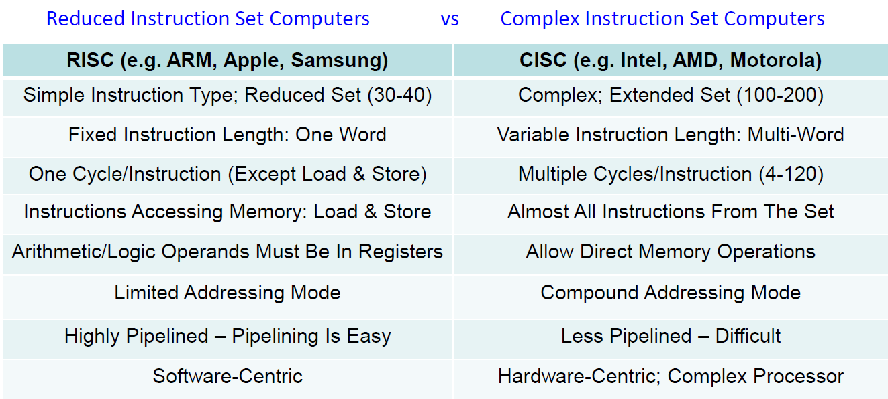

## Data Representation

|  |  |
| --- | --- |
| Nibble | 4 bits |
| Byte | 8 bits |
| Word* | 16-64 bits **32bits for STM32 32-bit ARM** |

*Half of it is known as halfword, architecture dependent

## Number Systems

|  |  |  |
| --- | --- | --- |
| Binary | 0b | Base-2 |
| Octal | 0o | Base-8 |
| Hexadecimal | 0x | Base-16 |

## Decimal Conversion Examples

To convert from decimal to hex, keep dividing by the base number. E.g for 2028(DEC) to HEX, 2028/16 = 126 R 12(C). 126/16 = 7 R14(E). 7/16 = 0 R7(7) Hence, 0x7EC

From hex to dec, multiply each bit its place value and sum the products

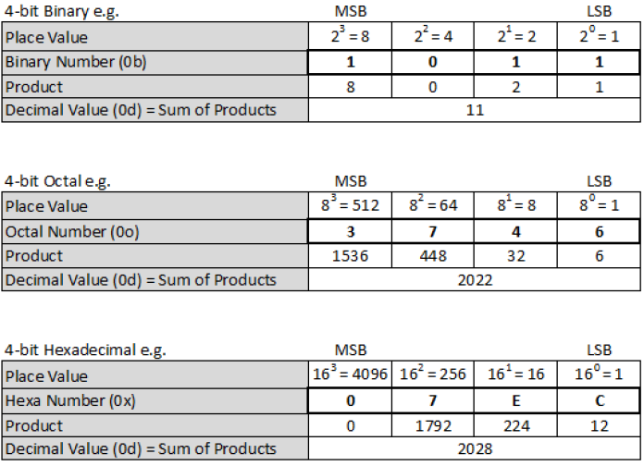

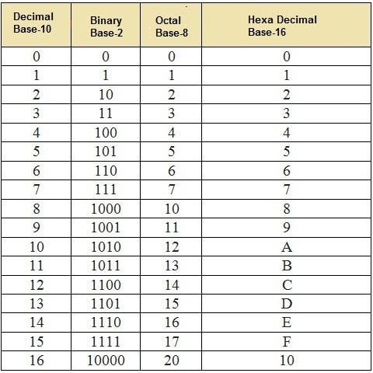

## Two’s Complement

Given a n-bit binary system the range is:

|  |  |
| --- | --- |
| Unsigned Integers | [0, $2^{n}-1$] |
| Signed Integers* | [$-2^{\left(n-1\right)}$, $2^{\left(n-1\right)}-1$] |

*Negative Numbers have a 1 in their MSB

*For hexadecimal F in the MSB is negative.

### Obtaining Two’s Complement

From **right to left**, starting from the LSB, look for the **first ‘1’** . Keep it and invert every bit to the left.

| Two’s Complement of a 4 Bit System | | | |
| --- | --- | --- | --- |
| 0111 | 7 | 1111 | -1 |
| 0110 | 6 | 1110 | -2 |
| 0101 | 5 | 1101 | -3 |
| 0100 | 4 | 1100 | -4 |
| 0011 | 3 | 1011 | -5 |
| 0010 | 2 | 1010 | -6 |
| 0001 | 1 | 1001 | -7 |
| 0000 | 0 | 1000 | -8 |

## Processor Components

|  |  |
| --- | --- |
| Arithmetic & Logic Unit (ALU) | For performing arithmetic & logic operations |
| Timing and Control Unit (CU) | For fetching program instructions, decoding & executing them in sequence & transferring the results back to memory |
| Registers | Fast storage, where each register holds one word of data |

## Registers

General Purpose Registers: R0 – R12 (Data & Addresses)

|  |  |
| --- | --- |
| Program Counter  (PC - R15) | Memory address of the current/next instruction |
| Instruction Register  (IR) | Current Instruction |
| Link Register  (LR - R14) | Return address when a subroutine/function is called |
| Stack Pointer  (SP - R13) | Memory address of the most recent data in stack memory |

* In ARMv7E-M, there are only 16 accessible registers, R0 to R15.

## Byte Addressability

An address is addressed to each byte. Each word is 32 bits.

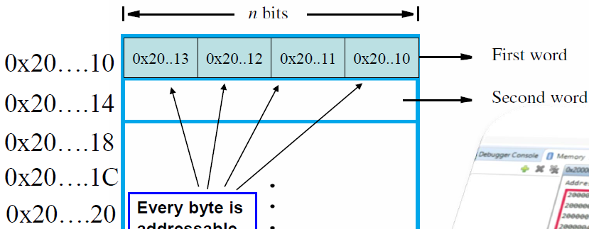

## Endianness

Internal ordering of a sequence of bytes in computer memory, which byte is placed into the lowest address byte.

|  |  |
| --- | --- |
| Little Endian: LSB First(32-bit ARM)   | Big Endian: MSB First   |

For 32-bit arm context:

Control access & instruction fetches are always little endian, but data access can be set as either big or little endian.

## Memory Opearations

CU initiates transfer of both instructions and data between memory & processor registers.

### Load & Store Architecture

Only LDR and STR have access to memory operations, operands for arithmetic and logic instructions must either be in registers or hard-coded.

## RISC Execution

1. Address for first instruction placed in PC

2. CU **fetches** and **executes** instructions

|  |  |
| --- | --- |
| Fetch | Execute |
| CU reads value in PC for address of current instruction and places the instruction into IR | CU decodes instruction in IR and performs operation. PC is then incremented to point to next instruction |

3. PC register incremented by 4 by default unless told otherwise via branching and looping

# Arm Assembly Language

## Calling Assembler Function from C

* Call assembler function from C program extern int my_asm_func(int x, int y); with max 4 input parameters(R0,R1,R2,R3) and 1 output parameter(R0).
* Define assembler function in asm(.s) program and use BX LR to return to C Program.

## Glossary Terms

Optional terms: Items bracketed by { }

Op2: Flexible second source operand that can either be a constant (e.g #0xFF), or a register with optional shift. (e.g R2, LSL #0x04)

Prefix S- or U-: Signed or unsigned operation of instruction.

Suffix -S: Updates condition code flags according to result.

*S/U MUST be specified for division

Label: symbolic representations of address

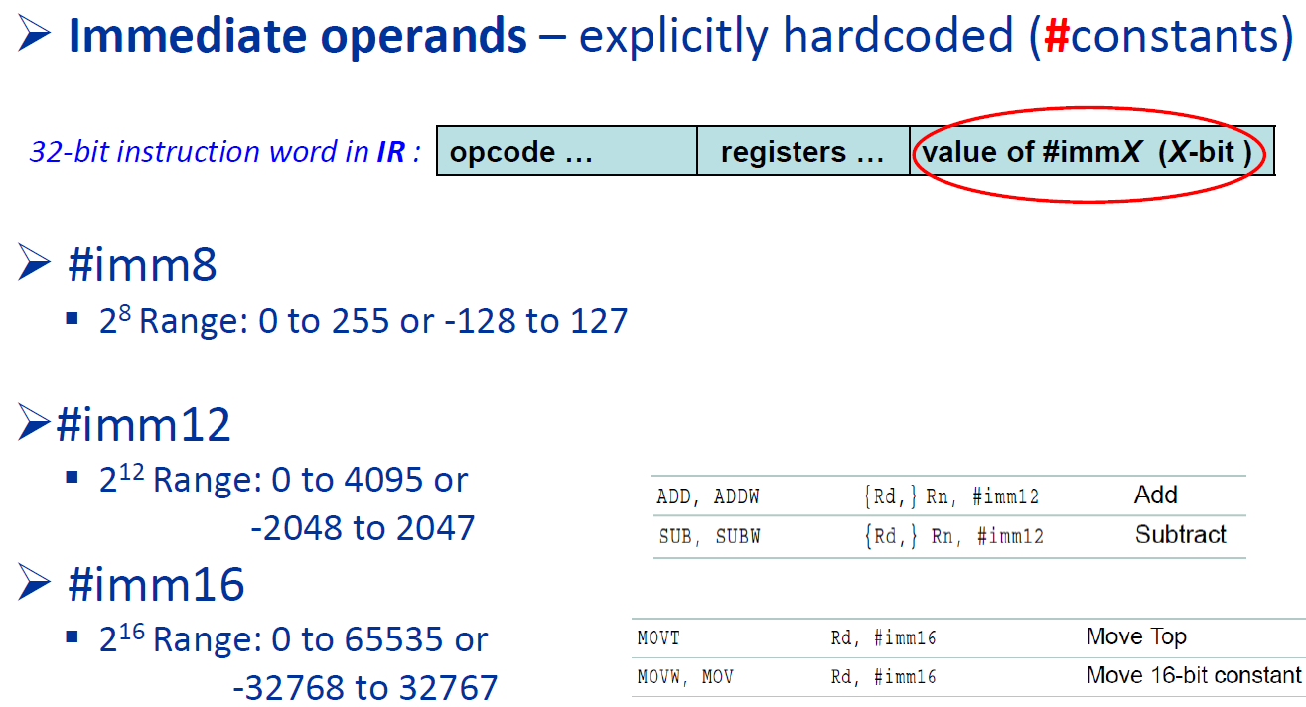

### Condition Code Flags

|  |  |
| --- | --- |
| N | 1 if result $<0$, else cleared to zero |
| Z | 1 if result $=0$, else cleared to zero |
| C | For **U** operations, set if:   * Result of addition $≥2^{32}$* Result of subtraction $≥ 0$ |
| V | For **S** operations, set if:   * Result of addition, subtraction, or compare: result $≥2^{31}$ or result $≤-2^{31}$ |

## Memory Allocation

### Constants:

|  |  |  |
| --- | --- | --- |
|  |  | Assembler Directive |
| .equ | Sets value of symbol to expression like #define | Start |
| .word | Allocates word-sized amount of storage space in that memory location | End |

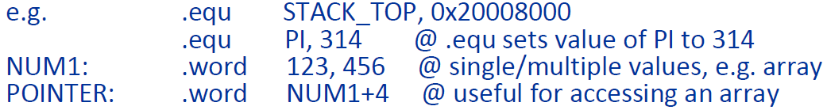

### Static Variables



Reserves 4 bytes, that retains value globally. Lifetime is for the entire run of the program.

*All directives do not require a # to specify it’s a constant.

## Offset Addressing(Standard)

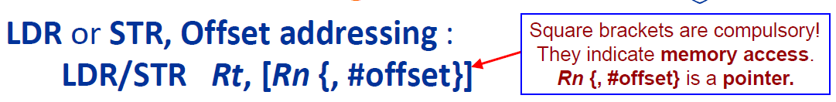

EA: Rn + #offset

No change to Rn

## Offset Addressing – Pre/Post Index

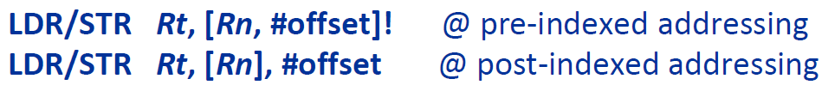

|  |  |
| --- | --- |
| Pre-Index | EA: Rn+#offset  Rn updated to be (Rn + #offset) |
| Post-Index | EA: Rn  Rn updated to be (Rn + #offset) |

## PC-Relative Addressing (LDR ONLY)

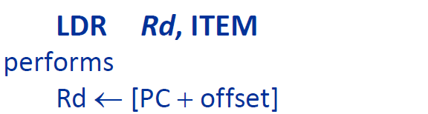

ITEM is a hardcoded label of range [-4095,4095]. LDR loads Rd with the value from a **PC-relative memory address (Base register is always PC)** specified by label, with offset calculated by the assembler.

## Pseudo-Instruction (LDR ONLY)

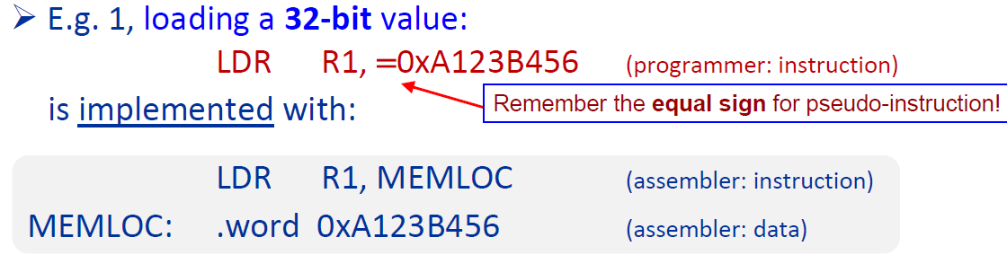

For loading 17–32-bit values/memory addresses. Assembler converts it to PC-relative LDR, allocates 1 word of memory fills it up with the value and lets the label(MEMLOC) refer to its address.

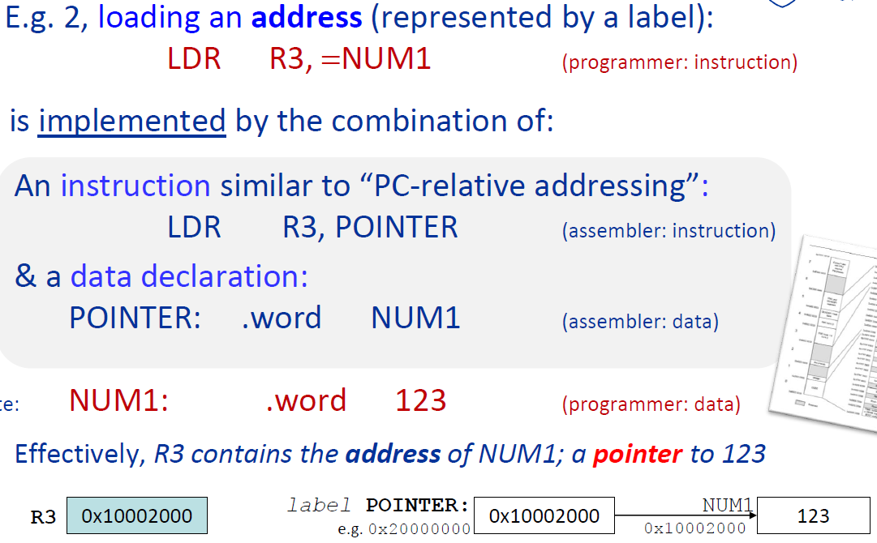

## Move Instructions

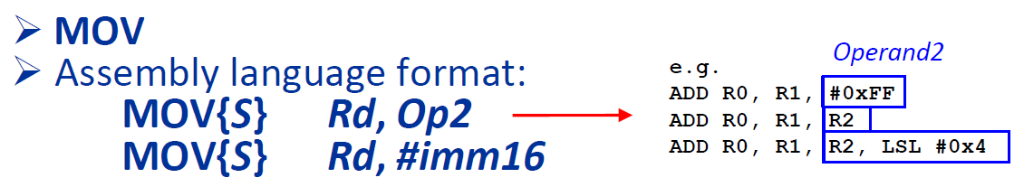

To transfer to a register an immediate constant value or from another register. Only N and Z flags are updated.

## Arithmetic Instructions

### Add and Subtract

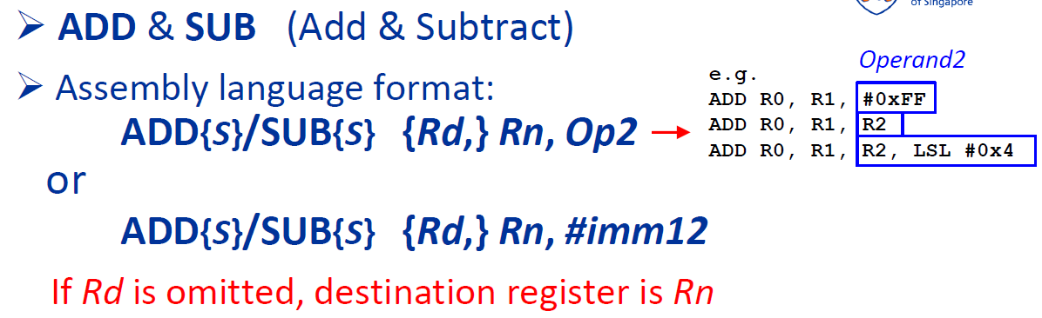

*Arithmetic operations can only be done through REGISTERS. Hence for ADD R2, R3, R4, the procedure is:

|  |
| --- |
| LOAD R2, A  LOAD R3, B  ADD, R4, R3, R2 |

### Multiply & Multiple with Accumulate

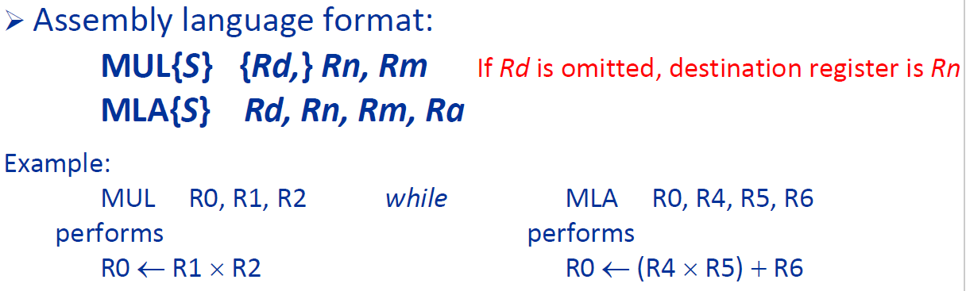

Note that both MUL and MLA only return the low-order 32 bits of the 64-bit product. No dependence on signed or unsigned calculations.

To get the 64-bit products use the long versions that come with the L Suffix with the unsigned(U) or singed(S) variants:

* UMULL, UMLAL, SMULL, SMLAL

### Division



Note that is no DIV. The sign of the operation MUST be specified.

## Compare Instructions

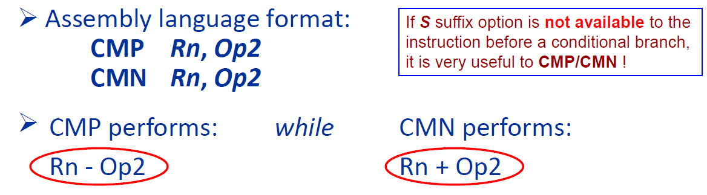

NCSV flags are updated as a result.

## Branch Instructions

L: Branch with link, writes the address of the next instruction in the PC to the LR,

X: Branch indirect, branch via a register that indicates the address to branch to.

### B{cond} label

The only conditional instruction that can be either inside or outside an IT block. All other branch instructions must be **unconditioned outside** an IT block and **conditional inside** the LT block.

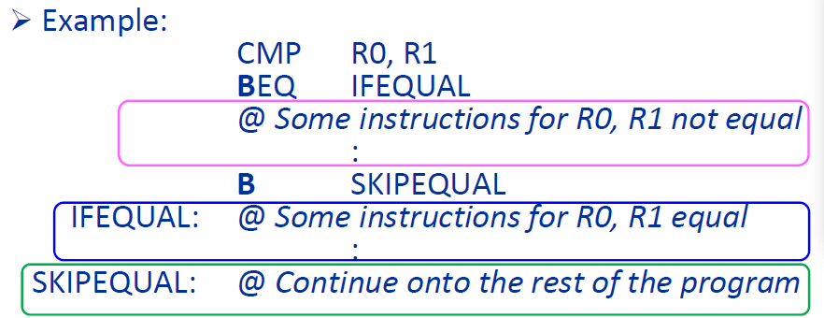

|  |  |
| --- | --- |
| B{cond} label | $$PC ←label$$ |
| BL(cond} label | $$LR ←PC; PC ←label$$ |
| BLX(cond} Rm | $$LR ←PC; PC ←Rm$$ |
| BX(cond} Rm | $$PC ←Rm$$ |

### BX LR

Use BX LR to branch back to the instruction mentioned. E.g

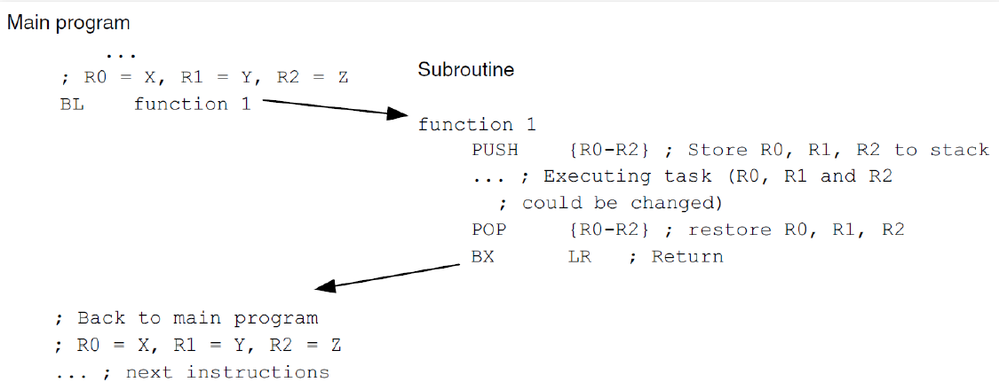

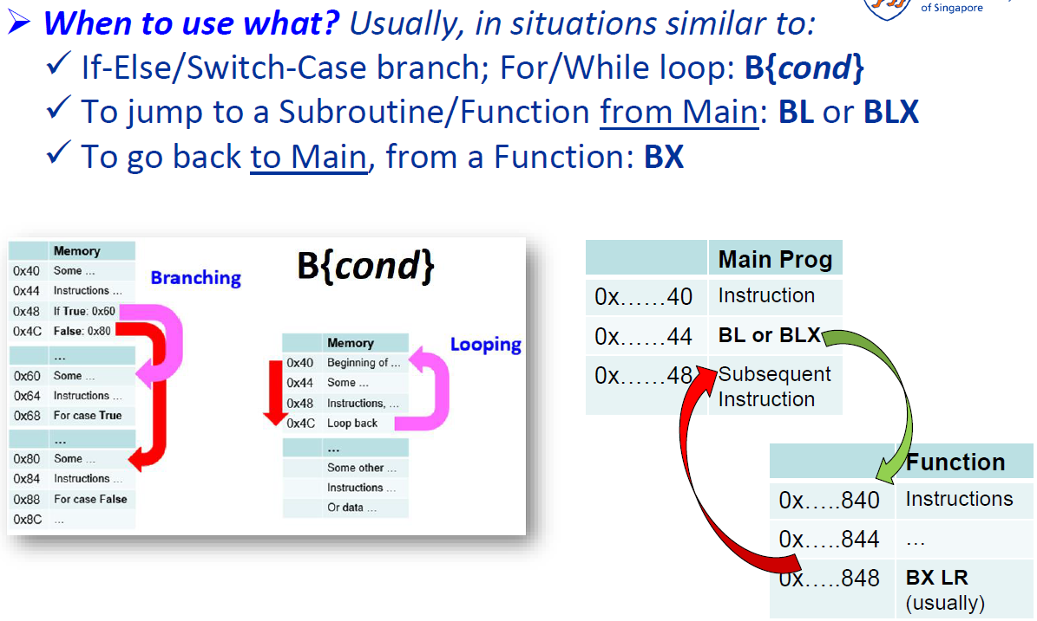

## Conditional Execution

1. Perform comparison/test or arithmetic/logical/move with suffix S to update conditions flags (NZCV)

2. Use condition code suffixes in branch instruction/IT block to perform conditional execution

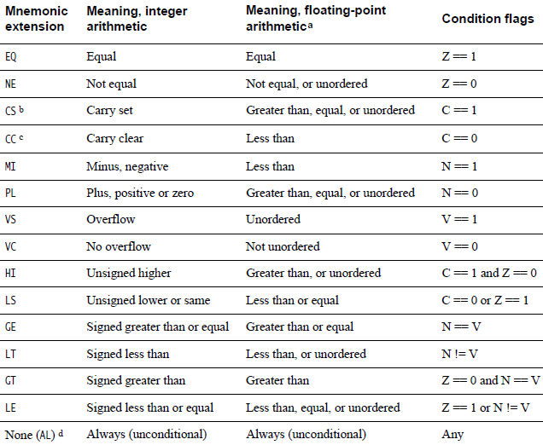

### IF-THEN block

Maximum 4 instructions and must start with T. So maximum is IT<x><y><z> <cond>. E.g

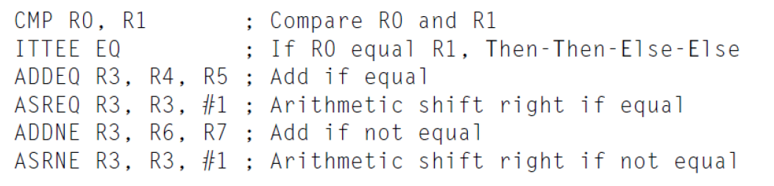

## Logic Instructions

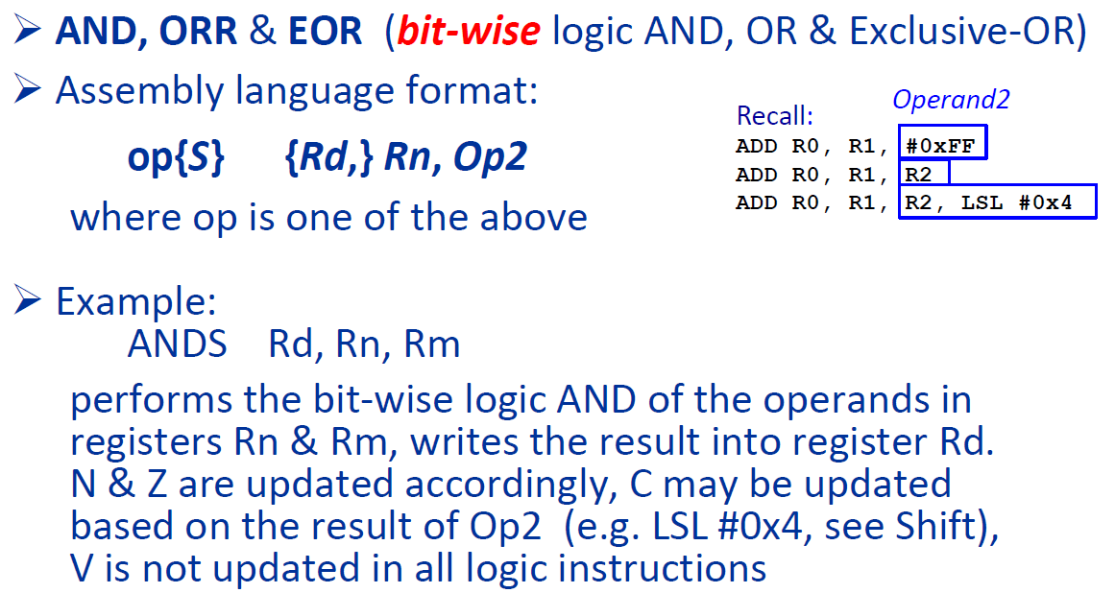

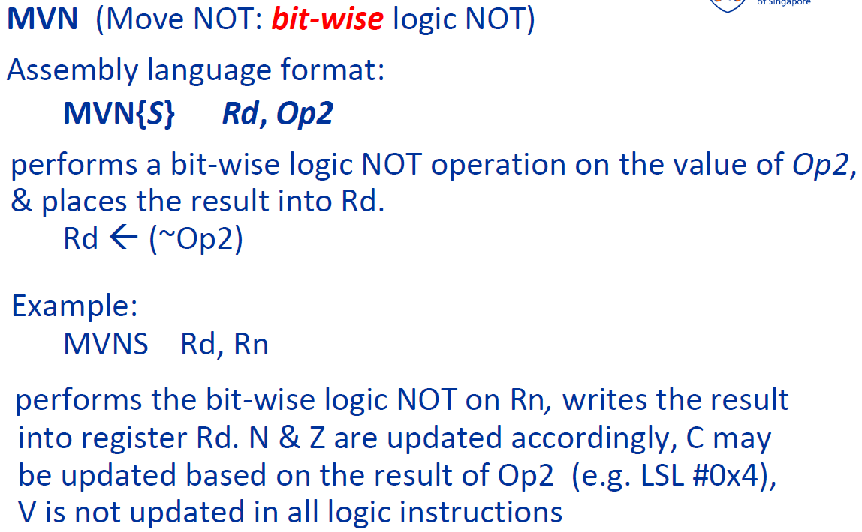

## Shift and Rotate

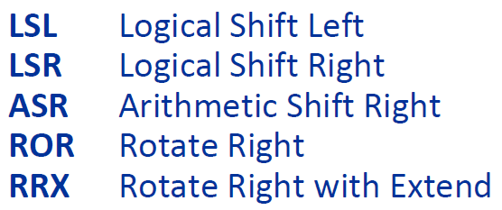

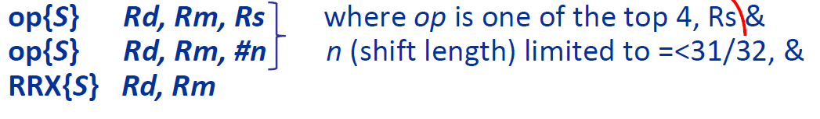

Note that S suffix should be used to update the carry flag.

|  |  |
| --- | --- |
| LSL |  |
| LSR |  |
| ROR |  |
| ASR |  |
| RRX |  |

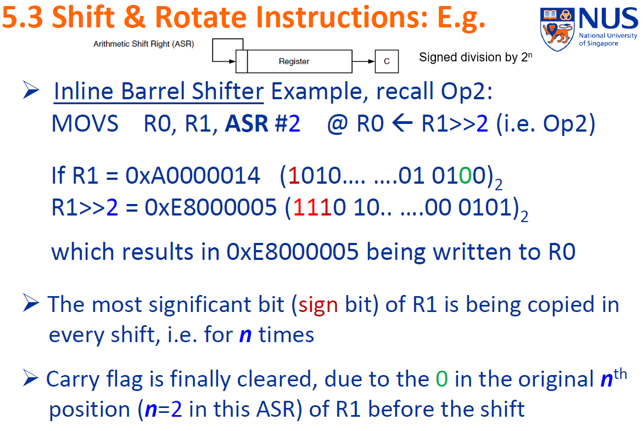

## Test Instructions



TST: Bitwise logical AND

TEQ: Bitwise logical Exclusive OR

Both update N & Z, C might be updated based on Op2. Note that the result is discarded unlike ANDS and EORS.

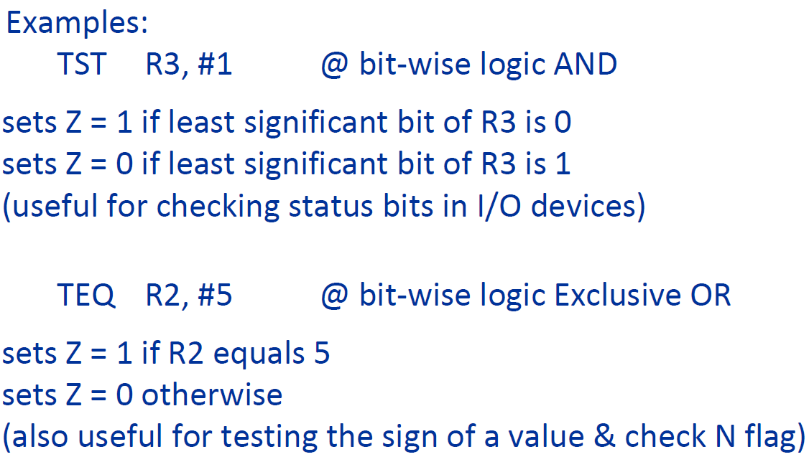

## Stack and Subroutine Functions

Data saved in a last-in-first-out manner and address specified by SP. Different stack implementations:

|  |  |
| --- | --- |
| Empty | Full |
| SP points to the next **free location** in the stack | SP points to the **most recent item** in the stack |

|  |  |
| --- | --- |
| Ascending | Descending |
| Starts from low and goes to higher memory addresses as items are **pushed** onto the stack | Starts from high and goes to lower memory addresses as items are **pushed**. |

By default, Cortex-M4 stack is **full descending,** with the common use to save register contents before data processing & then restore those contents when done.

PUSH at start, and then POP at the end.

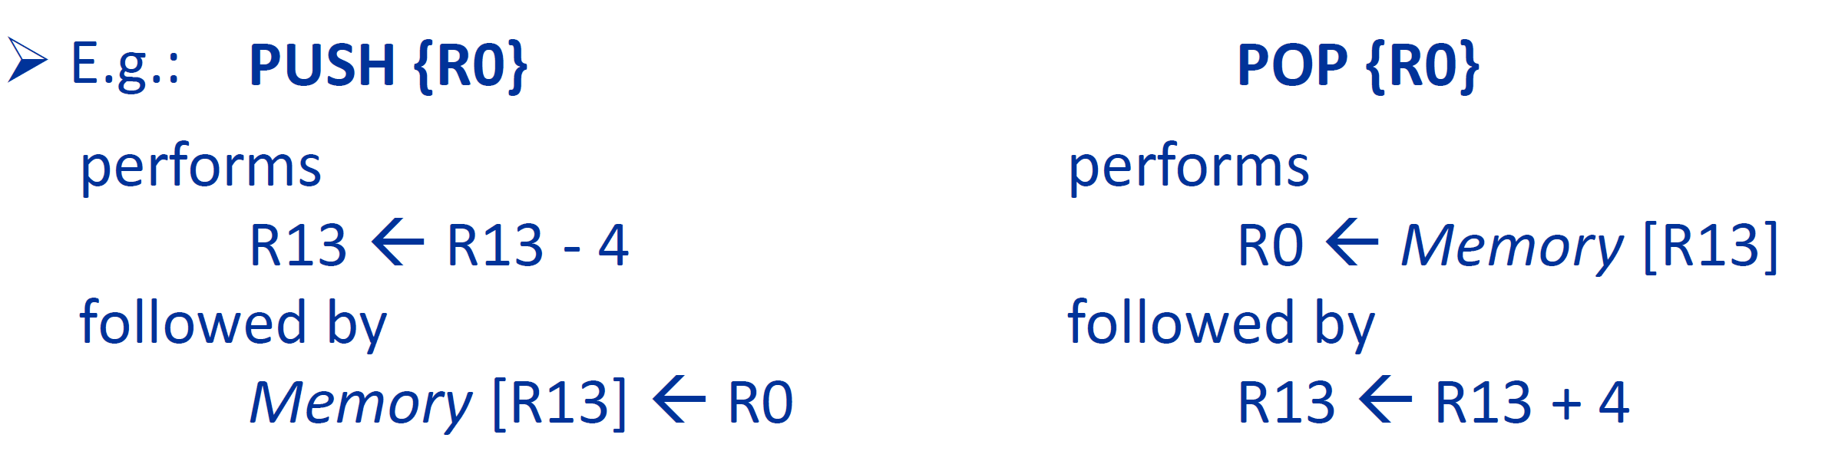

Note that curly braces here are not optional, and an array of registers can be pushed or popped. The order does not matter, and the lowest numbered registers from lowest memory address.

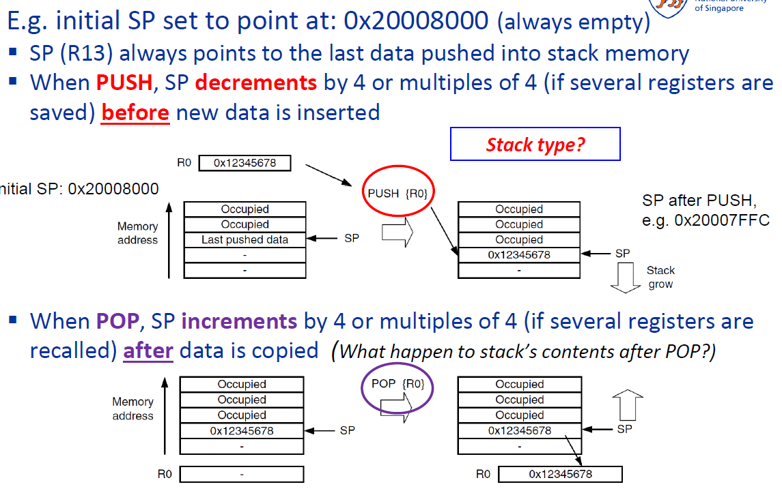

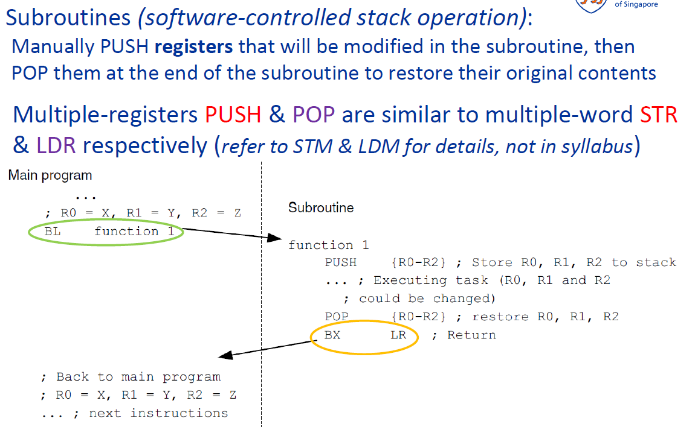

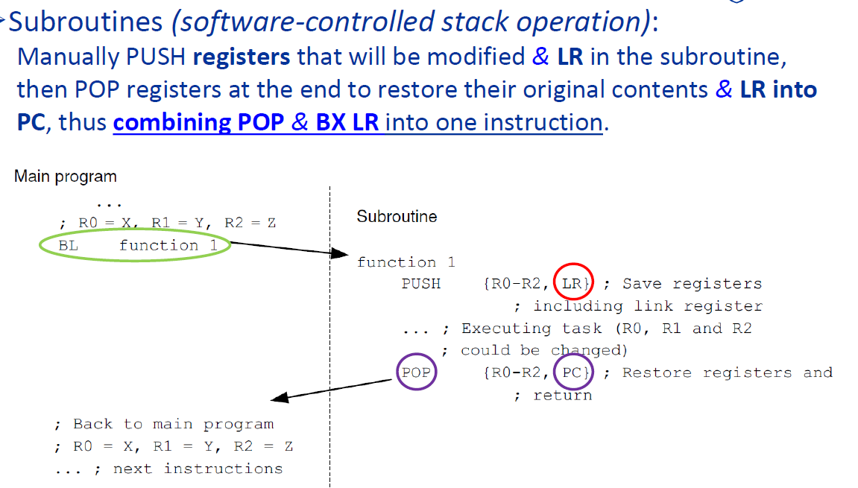

# Tutorial 2 Questions

### Determining the number of negative numbers in a list

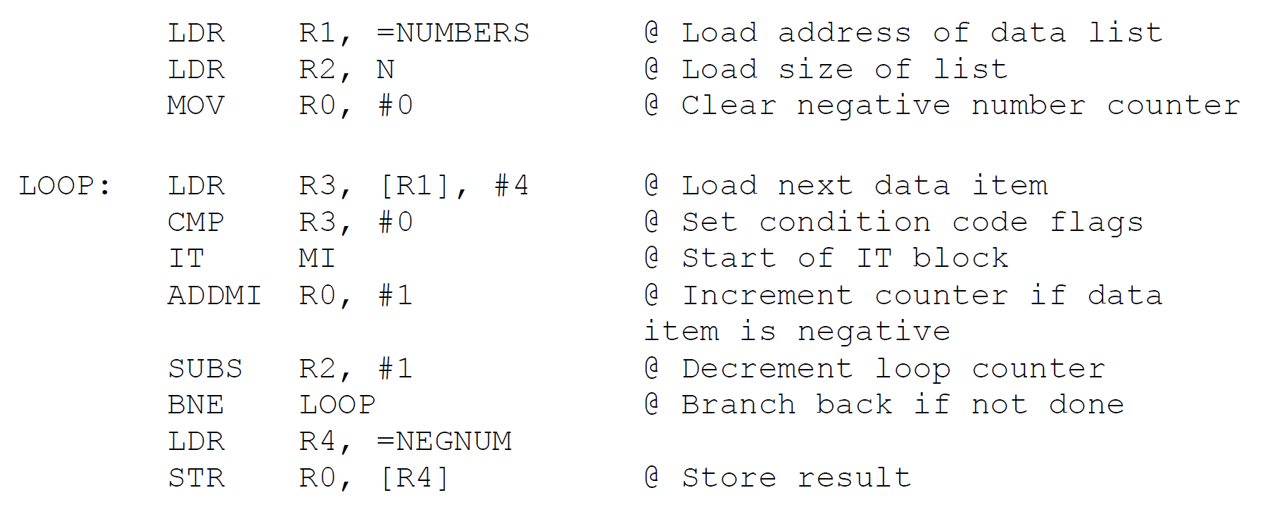

### Reverse the order of bits in register R2:

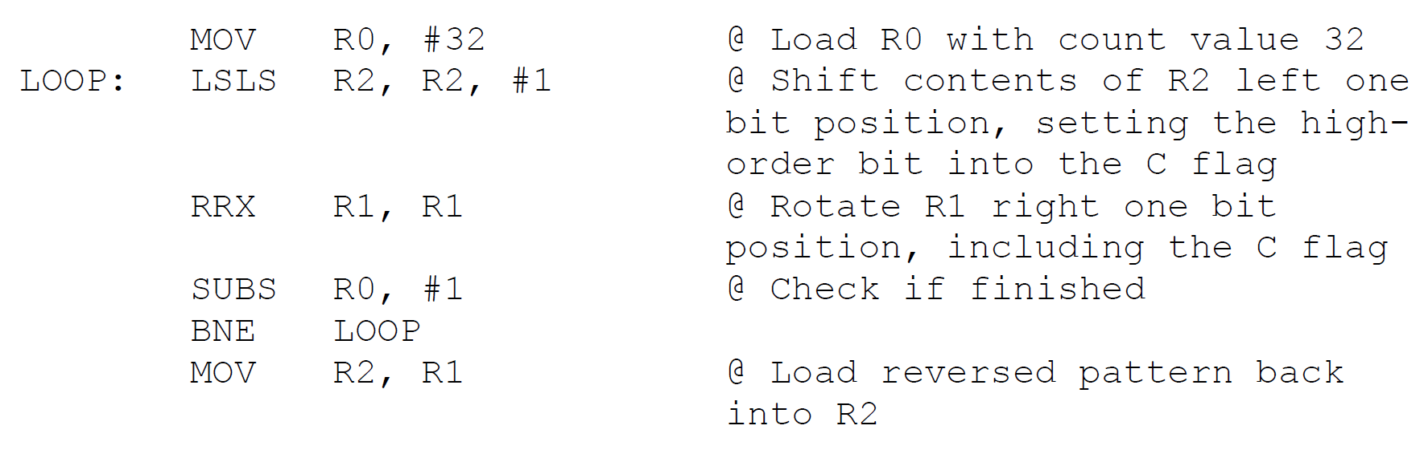

### Generate the first n numbers of the Fibonacci Series

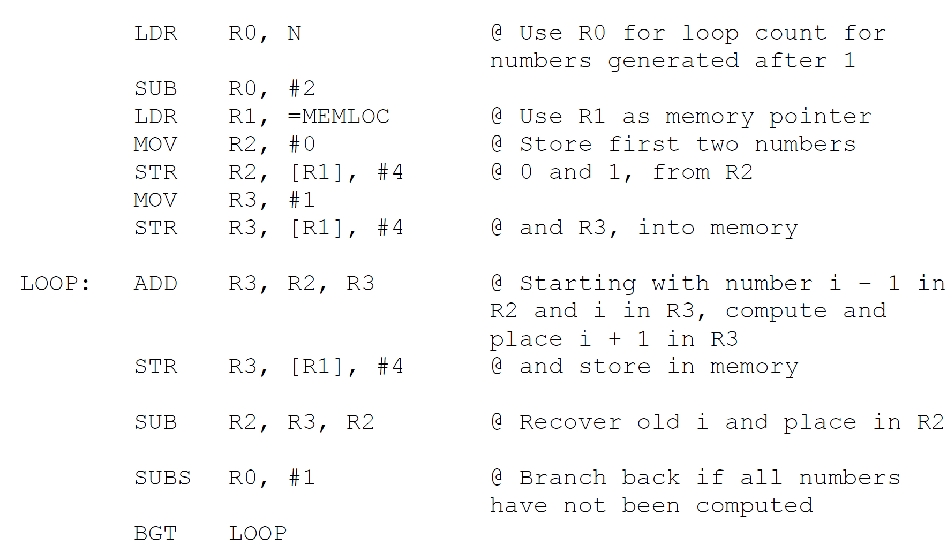

### Assignment 1 Insertion Sort

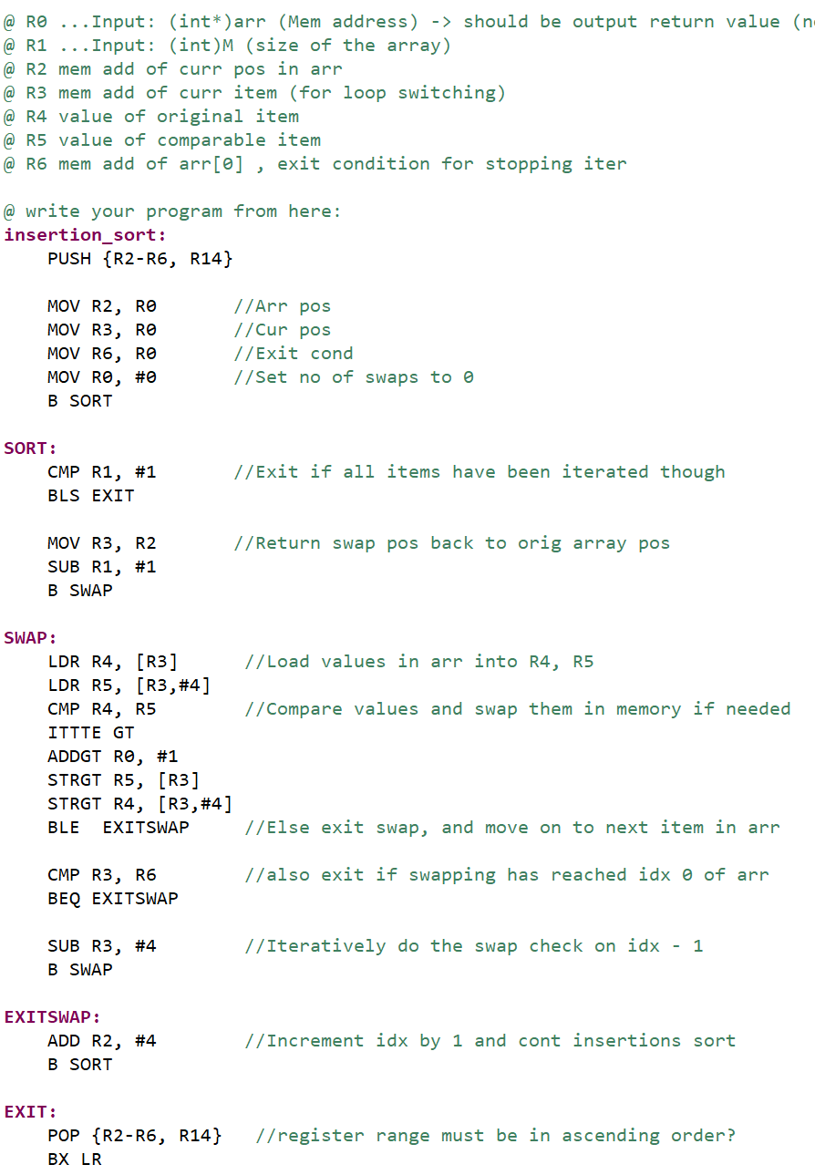

# C Programming

## Data Types

|  |  |  |
| --- | --- | --- |
| Built-in/Basic* | Derived | User-defined |
| Void, char, short, int long, float, double | Array, pointer, references | Struct, union, enum |

*Note that built-in data types are OS/compiler dependent. The minimum of a unsigned int is either 2 or 4 bytes.

Data types in stdint.h have a guaranteed, fixed data size.

E.g int8_t, uint8_t, int16_t, uint16_t, … int64_t, uint64_t

## Type Conversion

### Implicit(Automatic Type Conversion)

Compiler automatically promotes the lower type to the higher type to avoid data loss. However, data loss is still possible (int > unsigned)



### Explicit(Type Casting)

C syntax: (type)expression

Should be avoided as the result can be unpredictable.

## Variables & Constants

* Only alphanumeric characters & underscore are allowed.
* Cannot begin with a number. mdb1 is okay, 1mdb isn’t.
* Names beginning with ‘_’ are meant for reserved identifiers while a trailing ‘_t’ are reserved for standard types.

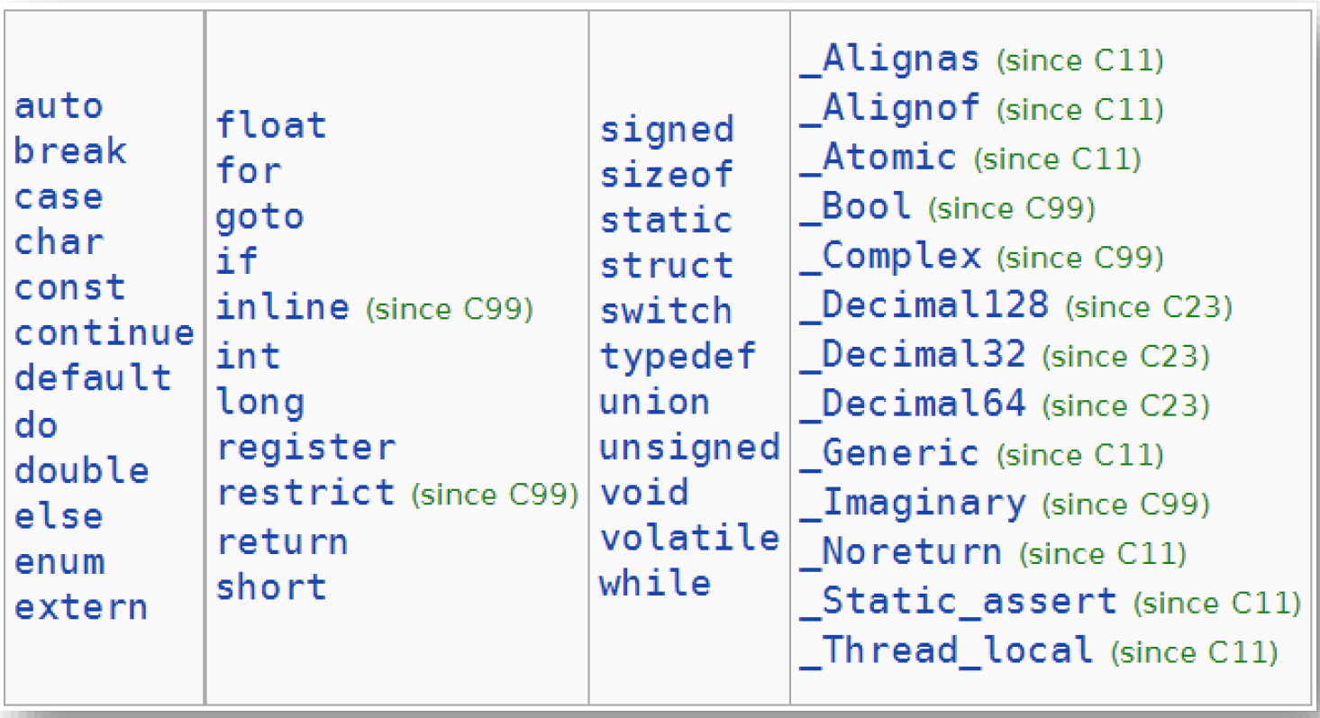

C keywords/reserved words are not allowed!

Note that #define is used to declare constants, but it **cannot be type checked**.

## Advanced Operators

sizeof()

Ternary(?:)

<condition>?<if true instruction>:<else instruction>

### Operator Precedence

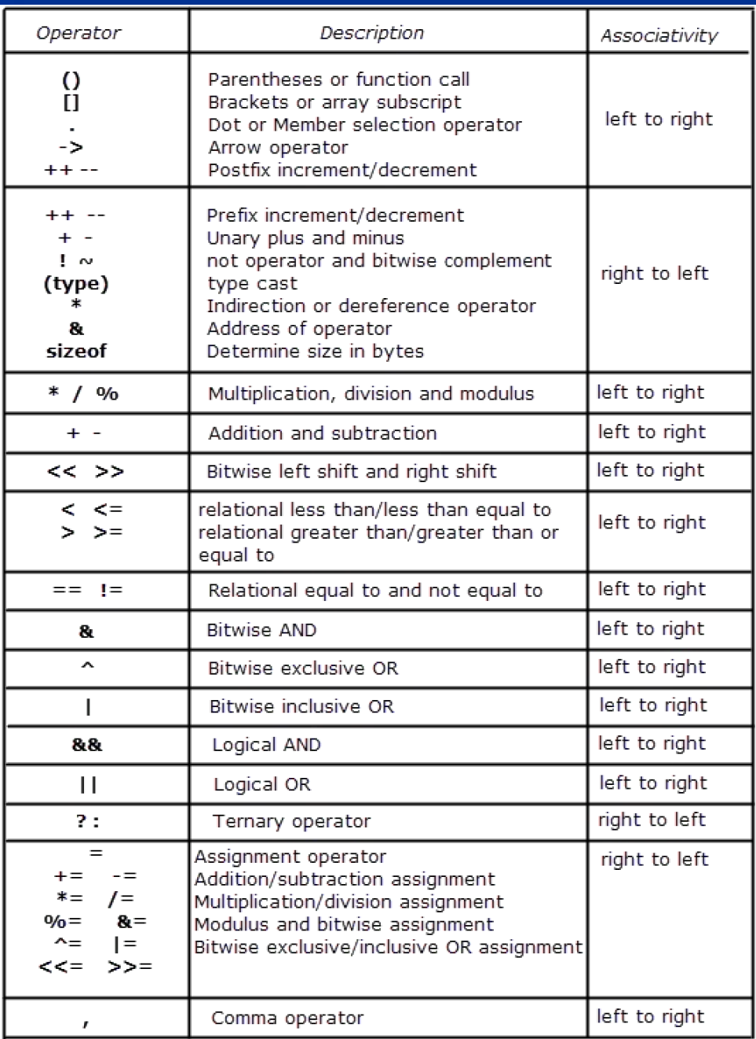

## Data types & size

|  |  |
| --- | --- |
| char | 1 byte |
| float | 4 bytes |
| int | 4 bytes |

## Selection

1. if-else

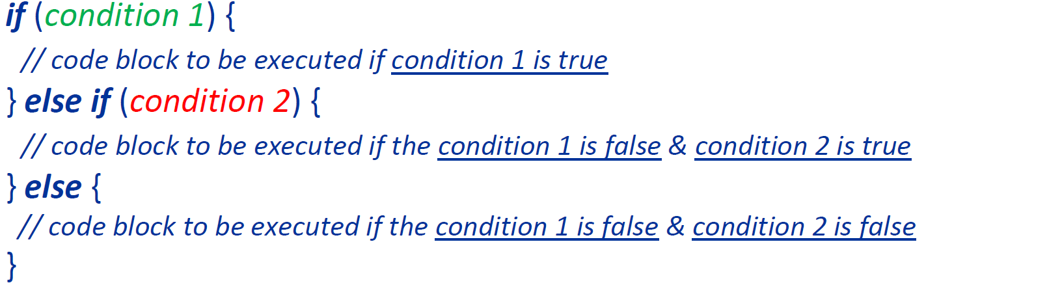

2. switch-case

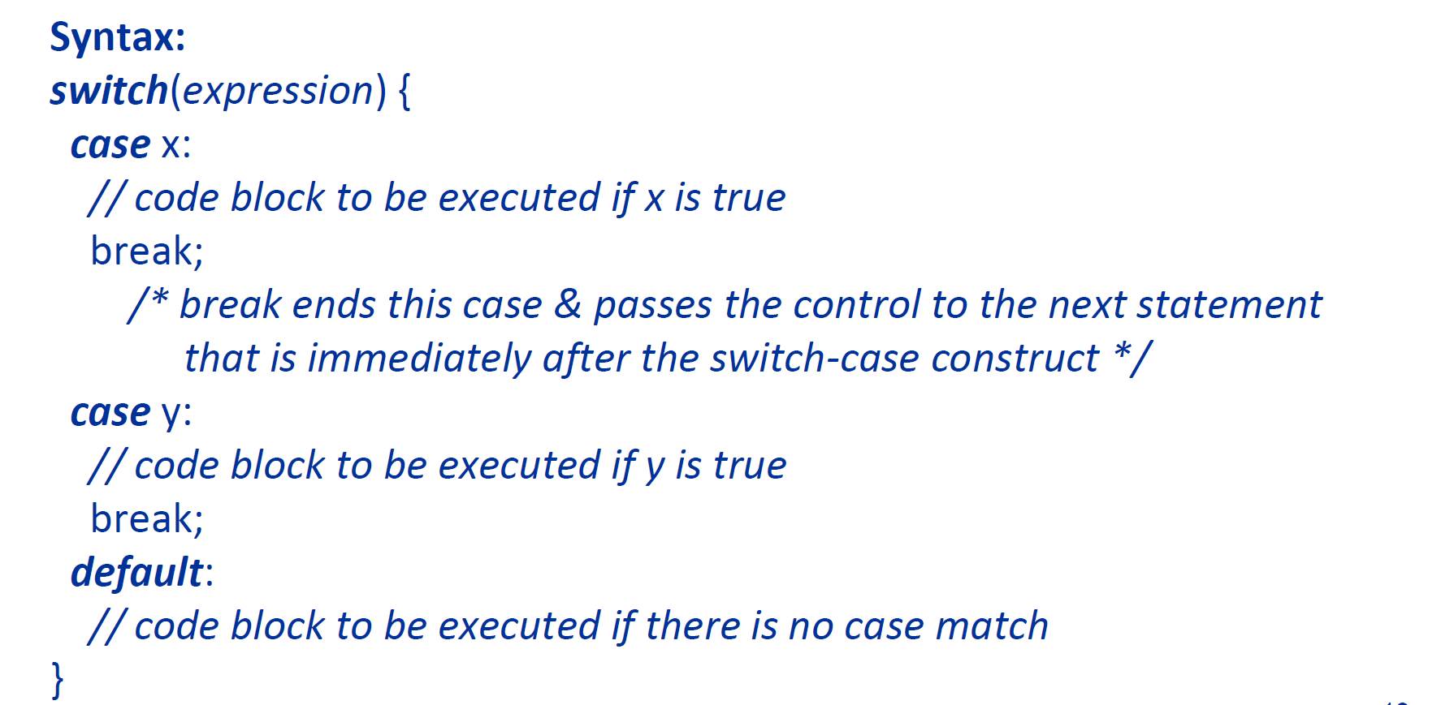

## Iteration

For, while, do-while. Break vs continue.

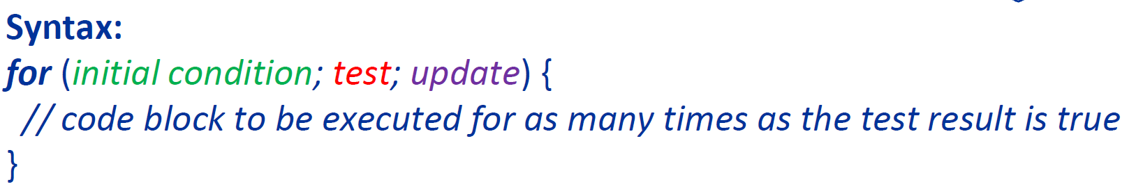

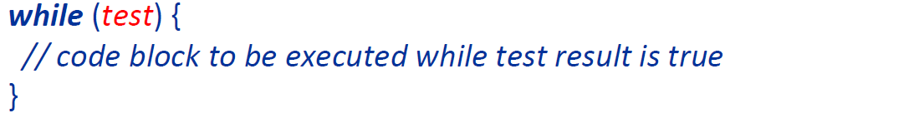

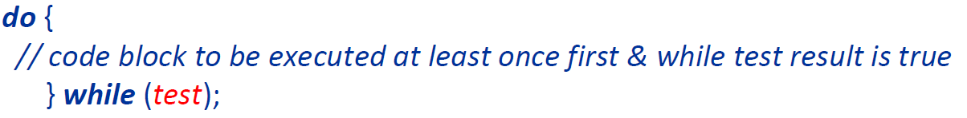

## Functions

Pass by value: value of parameter passed into the function. Value can be used but not changed.

Pass by reference: address of parameter passed into function. Value can be used and change. Format: int fx (int *a, char *b) {

### Function-like macros



### Printf()

Syntax: printf(“format ", arg1, arg2);

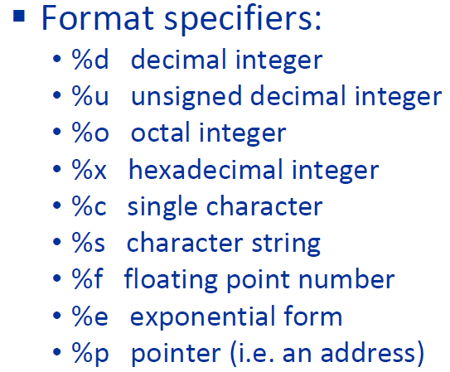

Note: %d, u, o, x, f & e may have l prefix for long

## Arrays

1D: int x[100];

2D: float mydata[8][25];

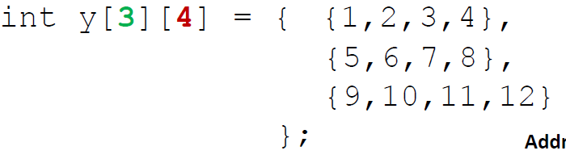

## Structures

### General

|  |
| --- |
| struct students {  char name[30]; int phone;  };  struct students st1;  st1.phone = 20; |

### Typedef

|  |
| --- |
| typedef struct ece /* the name ece is optional */{  char name[30]; int phone;  } students ; /* students is a “struct ece ” variable */  students st1; /* instead of struct students |

## Pointers

Pointer is a variable that stores the address of another variable.

&: Address Operator that evaluates the memory address of the operand

*: Indirection operator that evaluates the value of its pointer variable operand. Only operates on pointers.

|  |
| --- |
| int x = 10;  int *ptr = &x  int res = *ptr; // which will be 10 |

## Pointer to Structures

Pass address of struct to function instead of entire struct

* The time needed to perform the pass is independent of struct size.
* Allows the function to directly modify the struct and avoid making a copy of the struct variable.
* Allow efficient management of dynamically-memory-allocated structures.
* Anable access to variables defined outside of function.
* Enable easy return of multiple values from function.

|  |
| --- |
| typedef struct student{  int id;  char name[30];  }student_record;  void print_rec(student_record *X){  printf(“ID is :%d \n”, X->id);  }  void update_id(student_record *X)  X->id = 10;  }  student_record sr;  student_record *ptr_sr = &sr;  update_id(ptr_sr); |

Note that Ptr->member is short for (*Ptr).member and is used to access data members in struct pointers.

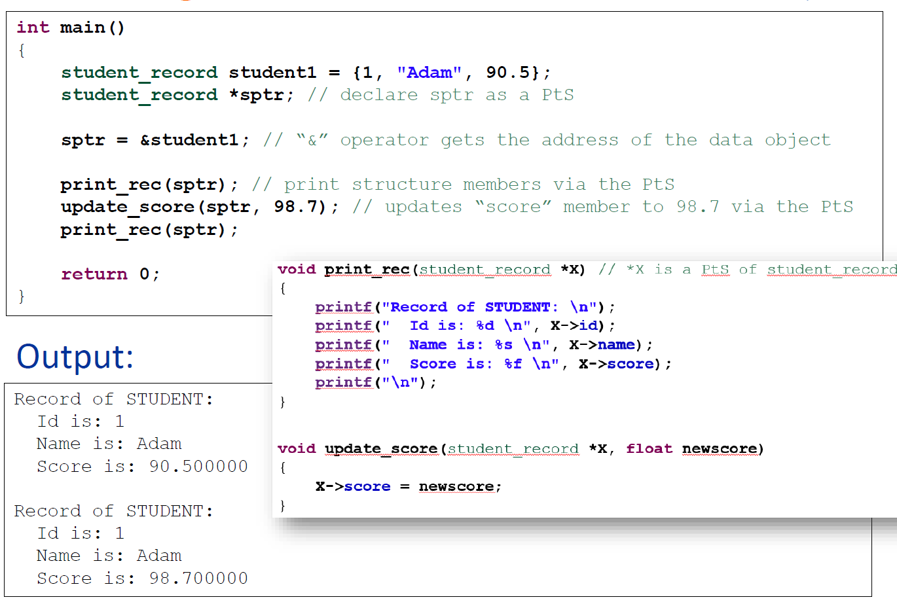

## Compilation Process

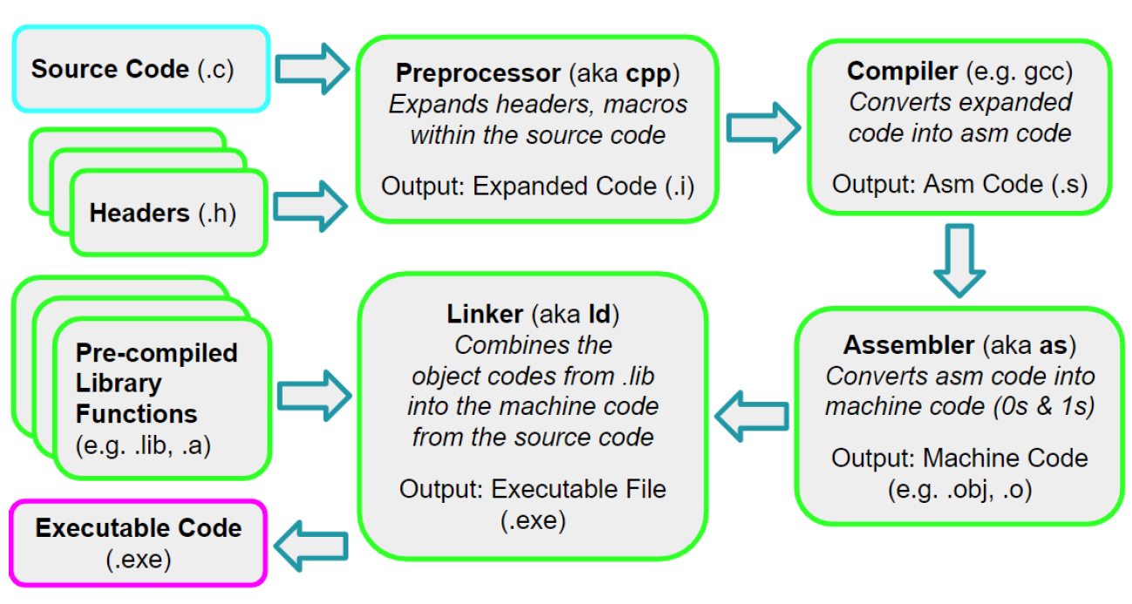

1. Preprocessor( )

2. Compiler()

- Note that assembly is specific to target processor, and the code can differ even if the same source code and compiler are used.

3. Assembler()

4. Linker ($.obj/.o, .lib/.a → .exe$)

## Tutorial 3 Questions

### Reverse order of 8 bits of a character and add 30:

### Fibonacci using Pointers:

# Interfacing Concepts

## Multi-tiered Bus Architecture

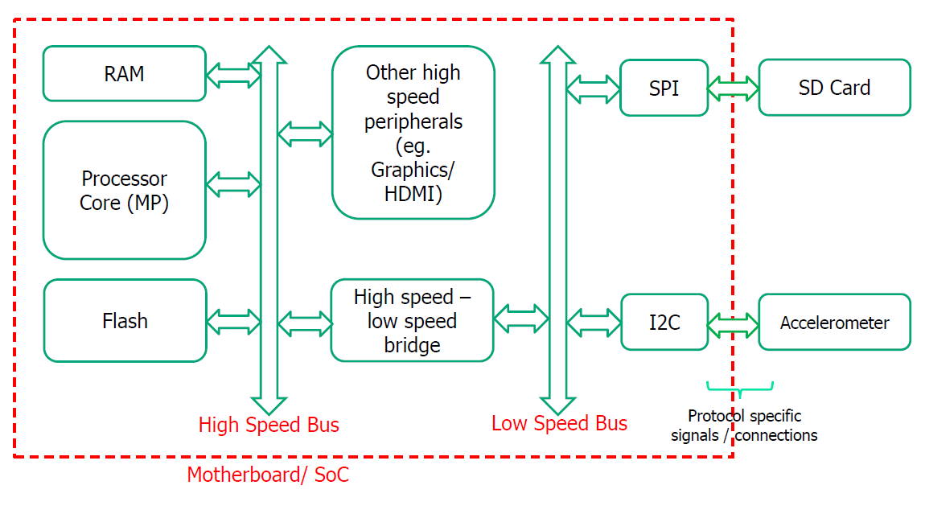

## Peripheral Registers

Accessed like memory using LDR/STR equivalent.

Status Registers: read by processor to know the status of hardware.

Control Registers: written by processor to give commands or control signals.

Data Registers: read(for input) and/or written(for output) to perform actual transfer of data.

### Abstractions

|  |  |
| --- | --- |
| CMSIS | Core Peripherals (NVIC, interrupts, SysTick) |
| HAL | On-chip Peripherals(GPIO, I2C, SPI, UART) |
| BSP | External Devices on baseboard(sensors) |

### Access

Memory-mapped IO(MMIO): Address for peripheral registers shares the address space with the memory (LDR/STR used)

Port-mapped IO(PMIO) Memory and peripherals are in separate address spaces, with separate instructions.

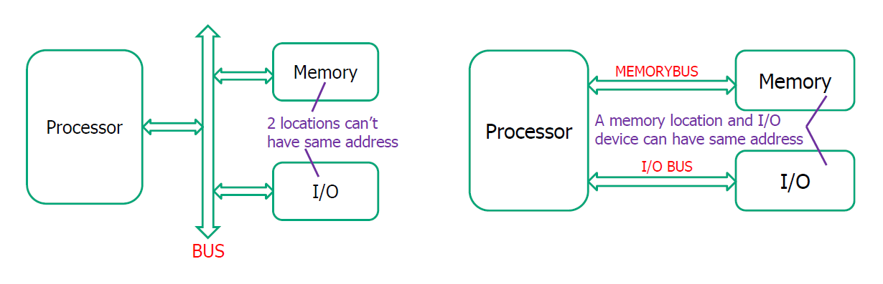

## Protocols

### Parallel vs Serial

Serial(SATA, I2C, SPI, UART)

Parallel(PCI, IDE, Printer Port)

* High speed low distance
* Suffers from bus skew (different signals, different speeds) and cross talk (signal interference)

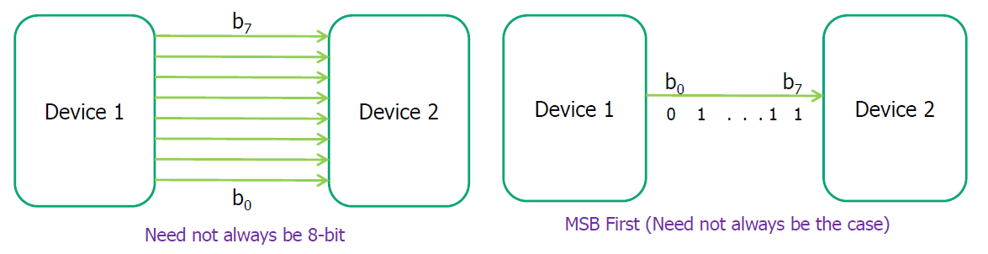

### Synchronous vs Asynchronous Protocols

Synchronous(SPI, I2C)

* One wire carries clock for time reference.
* Faster but issue of cross talk, bus skew

Asynchronous(UART,USB)

* Only data is transmitted, no clock.
* Receiver needs to recover timing info from data/control bits (start/stop etc.) – slower, complicated hardware.

|  |  |
| --- | --- |
| Synchronous | Asynchronous |
|  |  |

### Bus-based vs Point-to-point

|  |  |
| --- | --- |
| Bus-based: each device has a unique address (I2C, SPI, USB) | Point-to-point: two devices have a dedicated link (UART) |
|  |  |

### Master-slave vs Peer-to-Peer

Master-Slave(I2C, SPI, USB, AHB)

Only a master device can initiate a communicate, decides which slave should respond and may generate the clock.

Peer-to-peer(Ethernet)

Any device can initiate communication.

### Simplex vs Half Duplex vs Full Duplex

|  |  |
| --- | --- |
| Simplex (GPIO output to LED, or input from switches) | single, unidirectional link, one-way interaction |
| Half Duplex (I2C, USB 2.0) | one bi-directional link, devices take turns |
| Full Duplex (SPI, UART, USB 3.x) | at least two links, can transmit and receive at  the same time |

### Addressing: In band vs Out-of-band

|  |  |
| --- | --- |
| In band (I2C, USB):  address of the device being accessed, and data are sent through the same bus | Out-of-band(SPI):  separate address bus, a decoder enables (activates) the device |
|  |  |

# GPIO

GPIO ports: GPIOA – GPIOI with up to 16 I/O pins per port.

Direct connection to AHB2 bus allows fast I/O timing.

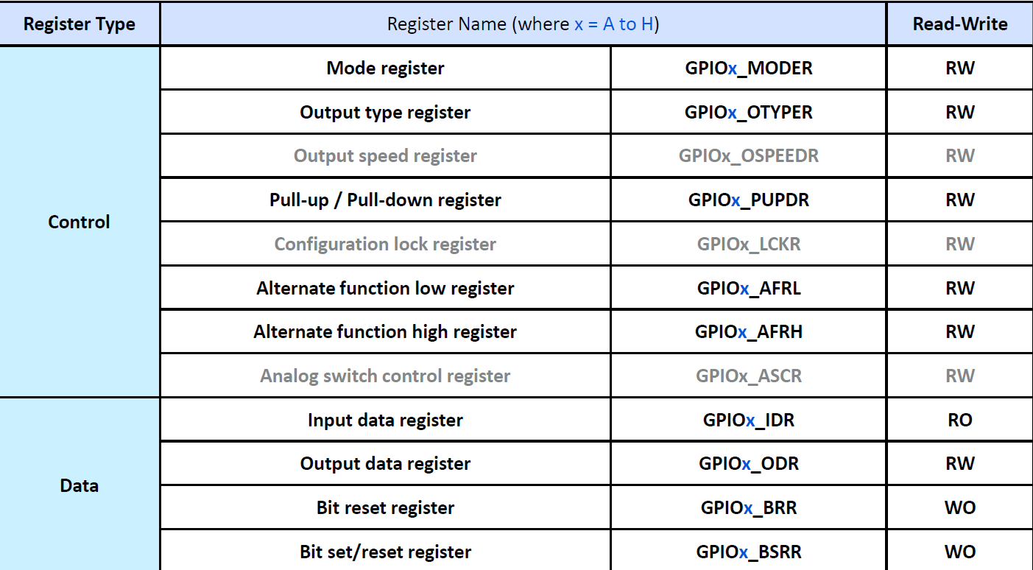

## GPIO Control Register – GPIOx_MODER

Used to configure the mode of pin y (15:0) of port x(A to H)

|  |  |
| --- | --- |
| 00 | Input Mode |
| 01 | GPIO Mode |
| 10 | AF mode |
| 11 | Analog Mode (reset state) |

## GPIO Control Register – GPIOx_AFRL/H

AFRL/H: Alternate Function Low/High. 16 possible functions so 4-bit value per pin. AFRL for pins 0-7 and AFRH for 8-15.

0000: AF0, 0001: AF1, 0010: AF2 … 1111:AF15



## GPIO Control Register: GPIOx_PUPDR

Active HIGH input – pull down. The vice versa.

|  |  |
| --- | --- |
| 00 | No pull-up, no pull-down used when pin is not an input, or when external device will driving a strong high or low and won’t be floating |
| 01 | Pull-up: Default input is high |
| 10 | Pull-down: Default input is low |
| 11 | Reserved |

|  |  |
| --- | --- |
| Active Low $→$ Pull-up | Active High $→$ Pull-down |

## GPIO Control Register: GPIOx_OTYPER

OTYPER: Output type register

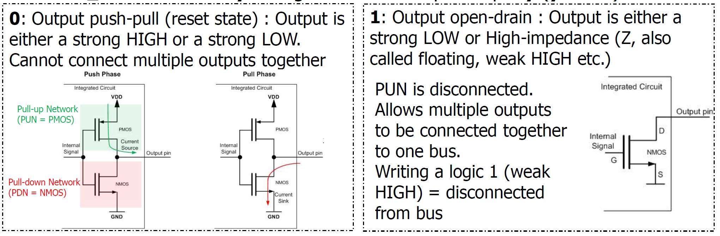

Open-drain mode can be used to interface between different logic levels or allow bi-directional communication between multiple devices with a single wire.

|  |  |
| --- | --- |
|  |  |

## GPIO Data Registers

Read data from the Input data register (IDR) and write data to the ODR. But its better to manipulate ODR bits using the BSRR or BRR, which are logical interfaces for affecting ODR.

* Allows for one action modification rather than $read →modify→write back$

GPIOx_IDR IDy: Logic Level read from port x pin y.

GPIOx_ODR ODy: Logic level output on port x pin y. Read-write, can read the output or write to specific bit while keeping the rest unchanged.

GPIOx_BRR BRy: for port x pin y. Writing 1 to a bit will reset that pin LOW

GPIOx_BSRR: port x pin y

BSy[15:0] writing 1 will set the pin HIGH. [PRIORITY]

Bry[31:16] writing 1 will reset the pin. To be used if there is a need to set and reset some pins at the same time.

## GPIO HAL Supporting Functions

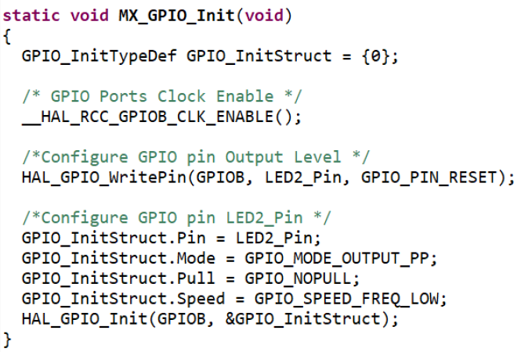

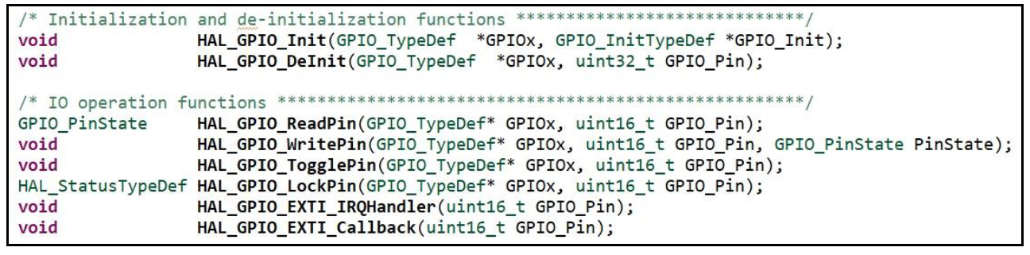

|  |  |
| --- | --- |
| EENG 383 - Lecture Notes | Active high $→$ OTYPER must be Push-pull. Write to BSRR (HIGH) to turn off LED.  Active low $→$ doesn’t matter.  Write to BRR (LOW) to turn on LED. |

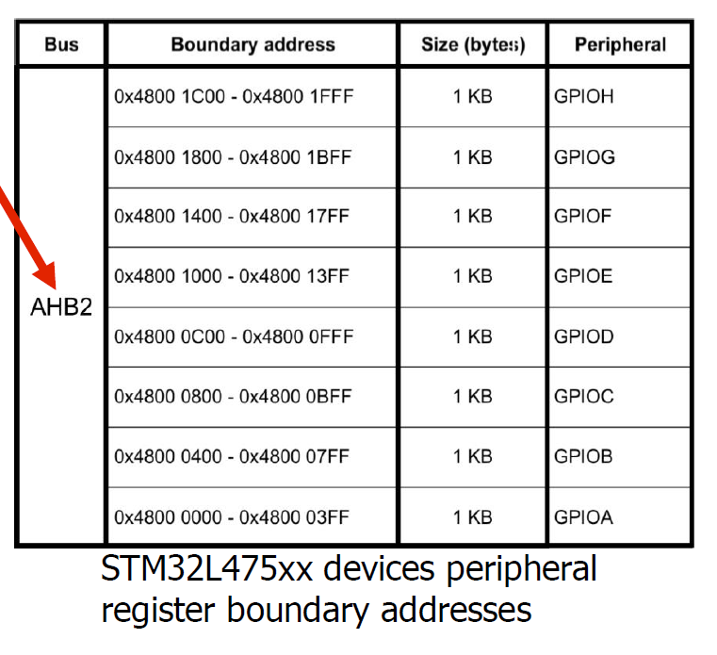

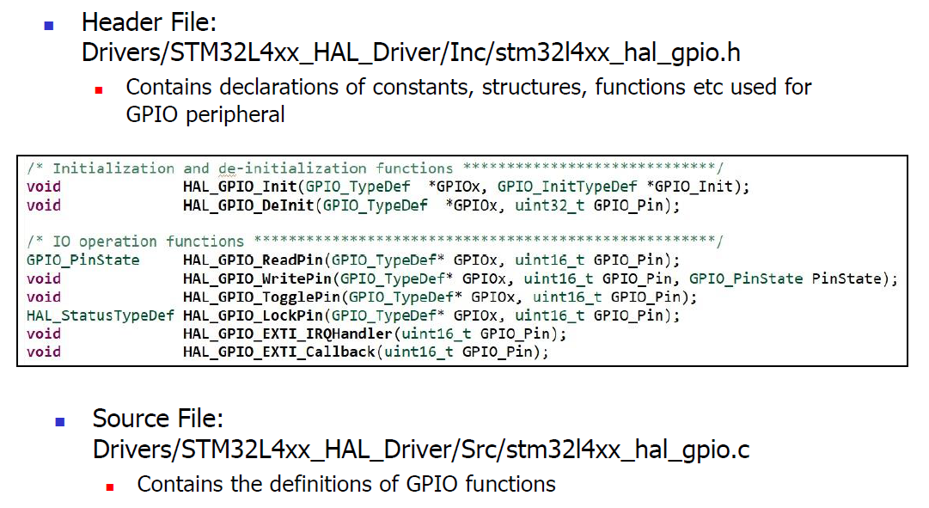

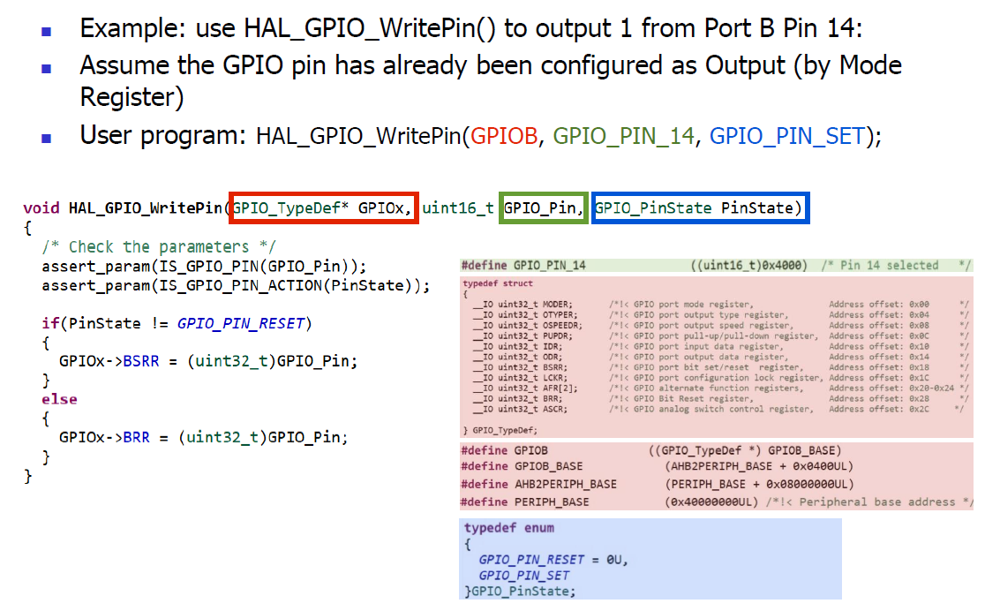

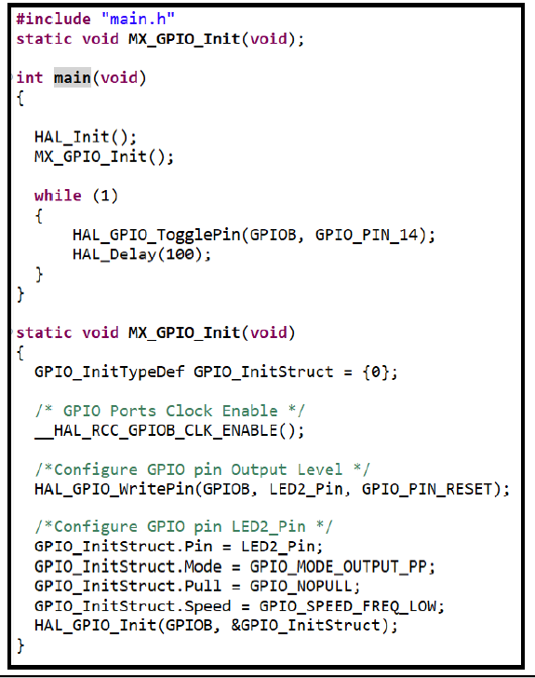

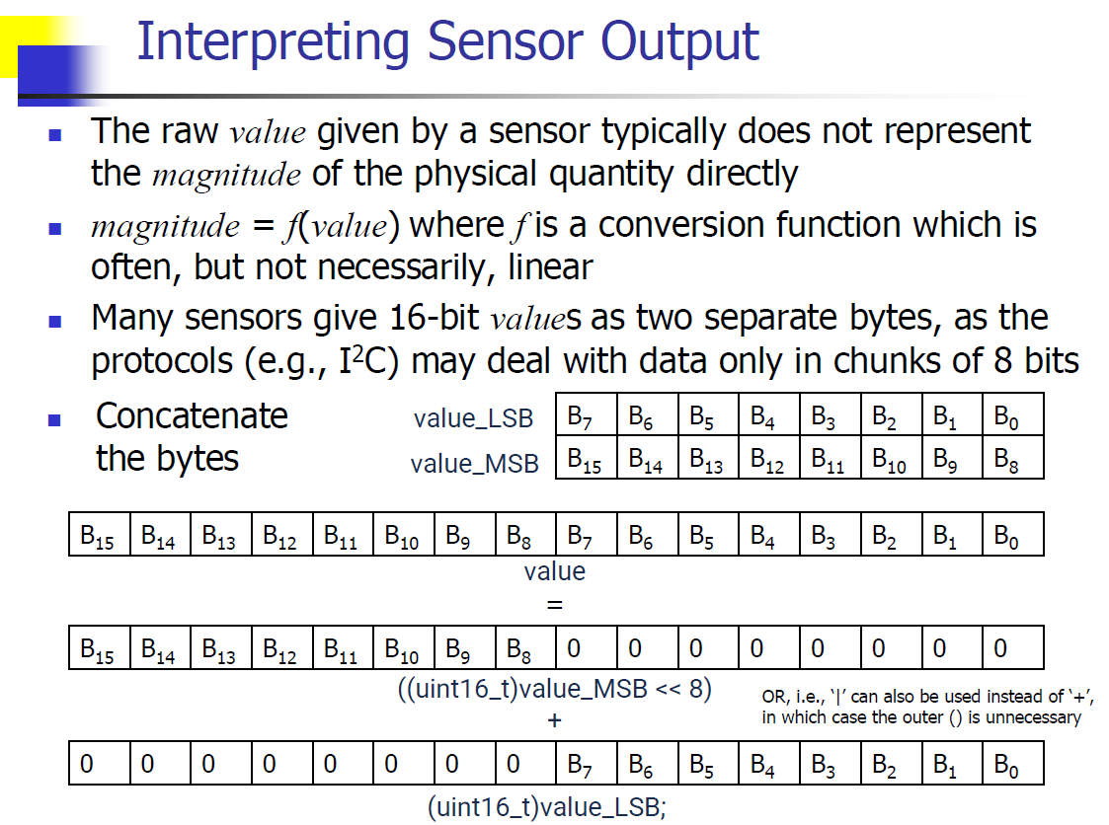

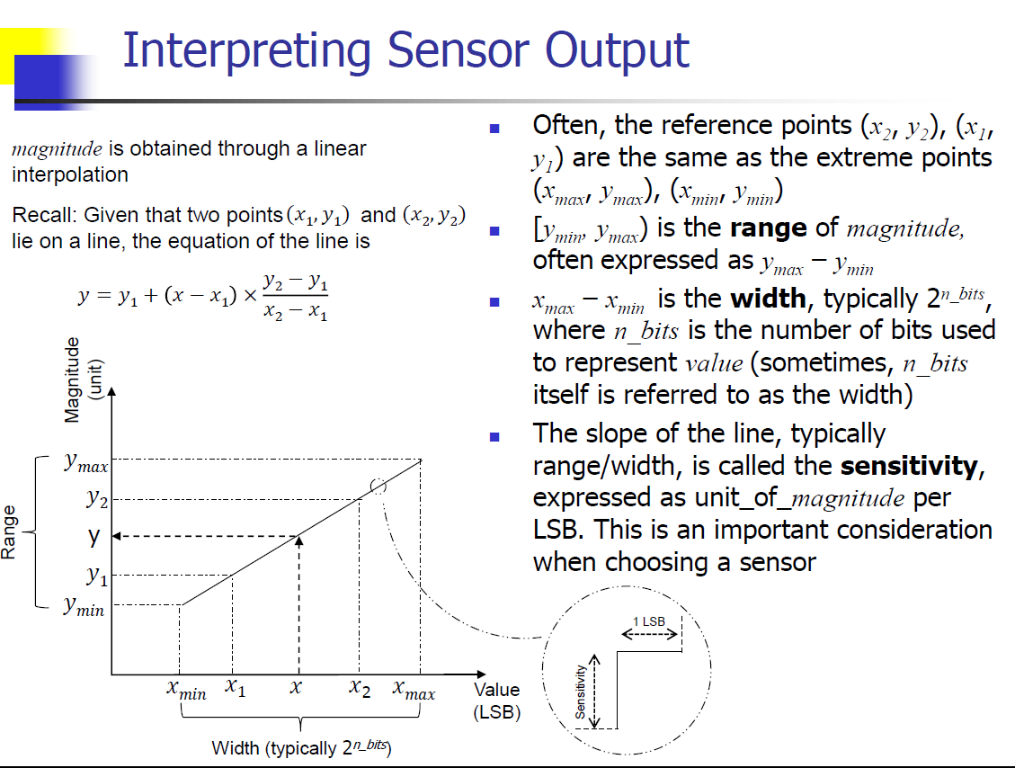

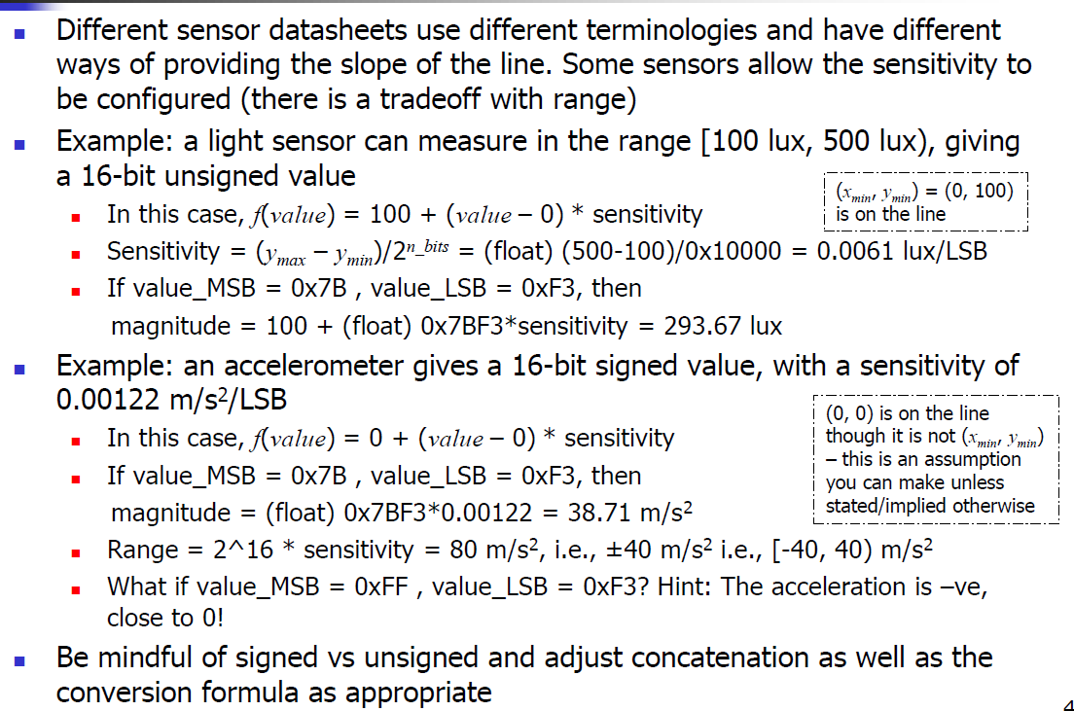

## Tut 4 Solutions

### Read BTN1 and turn on LED1

A push button BTN1 is connected to STM32L475VG port A pin 10. BTN1 is active low, and LED is active high. Assuming that the pins are already configured to be in the correct mode, write a C program to turn on the LED whenever BTN1 is pressed. (Direct register modification).

### HAL Configuration

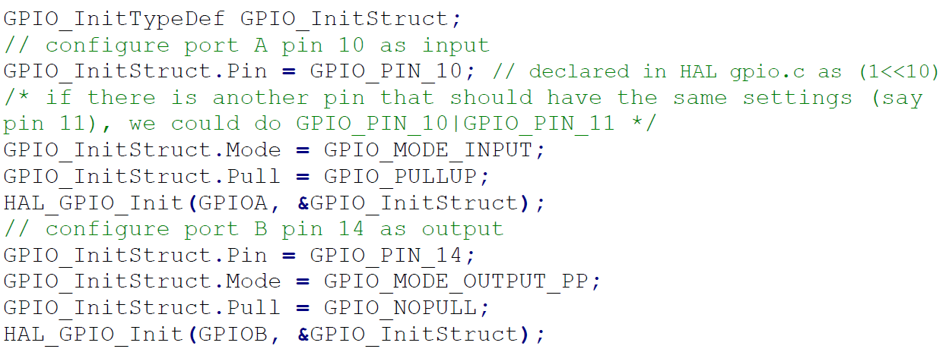

### Altimeter [Sensor] Reading

An altimeter provides the altitude above sea level in the range [-50 m, 150 m) as a signed 12-bit value, in the form of 2 separate bytes with the format A11A10A9A8xxxx (MSB) and A7A6A5A4A3A2A1A0 (LSB). If the sensor gives MSB = 0xAB and LSB = 0xCD, what is the altitude in metres? Note: x’s in the format denotes reserved bits / don’t cares – the values from these bits should be ignored.

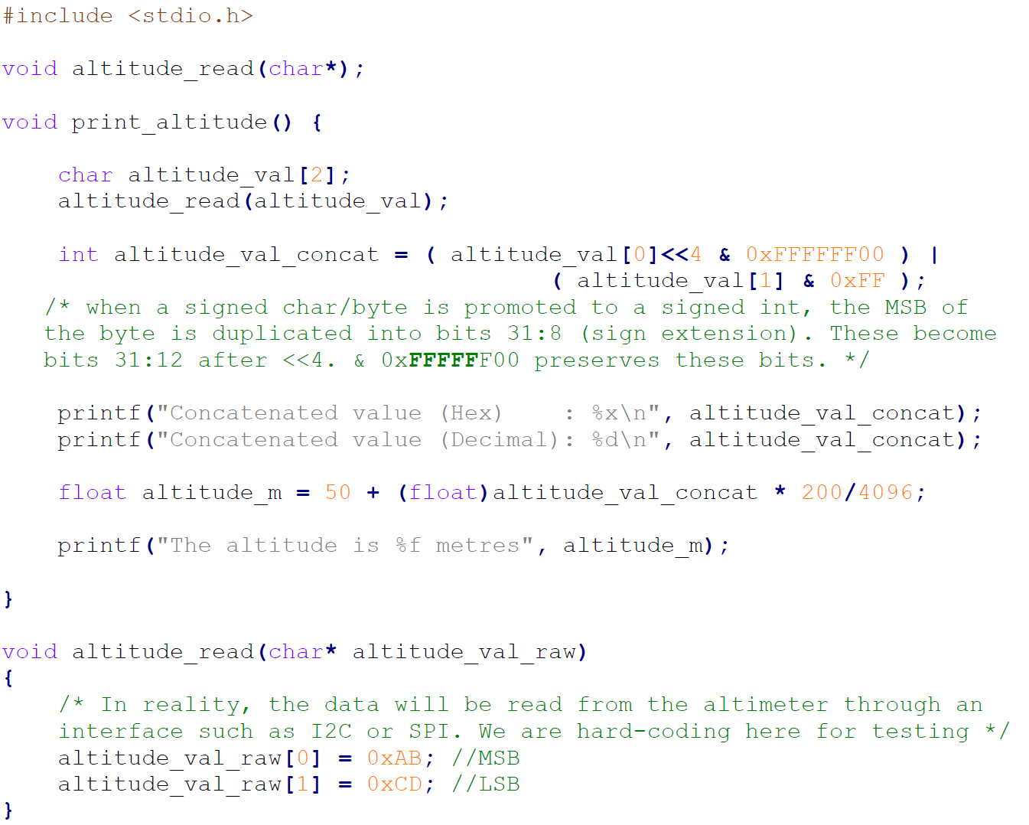

## GPIO References

### Mode(Input, Output, AF)

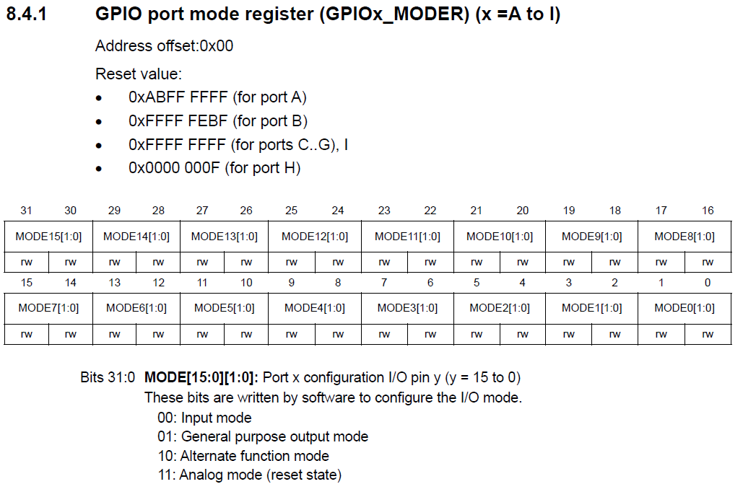

### Output Type (Push pull, Open-Drai)n

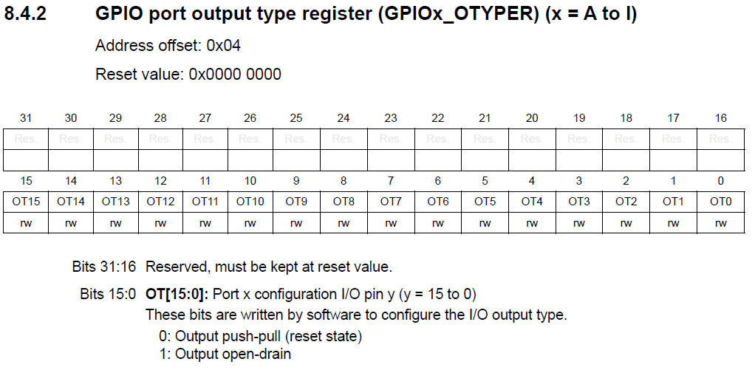

### Pull-Up or Pull-Down

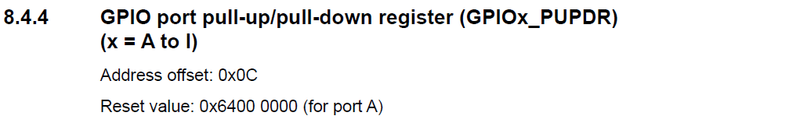

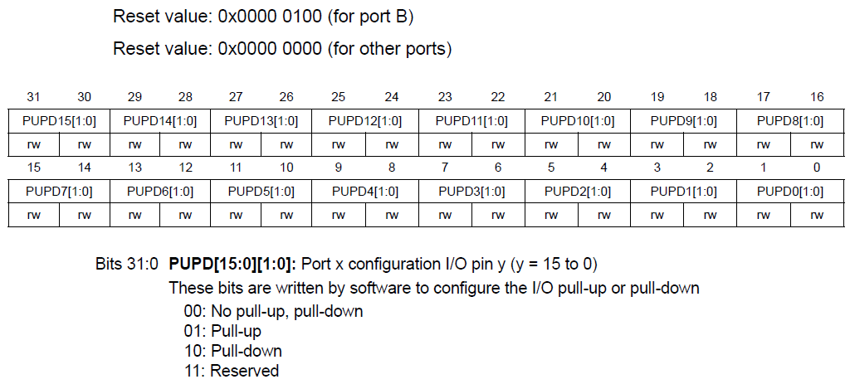

### Input Data

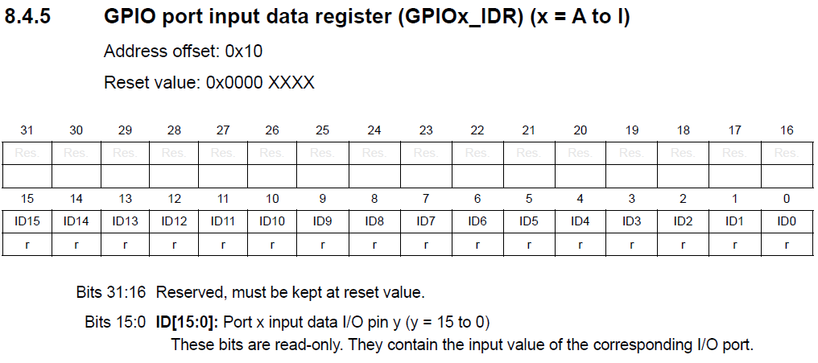

### Output Data

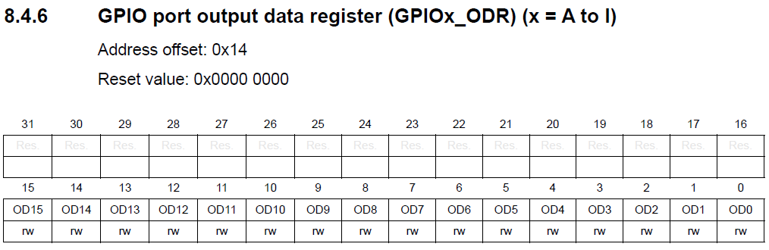

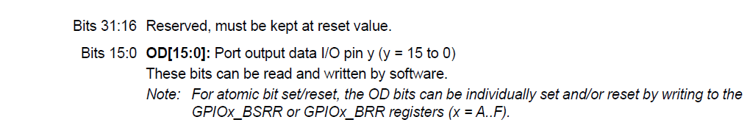

### Bit Set Reset(Output HIGH / HIGH & LOW at same time)

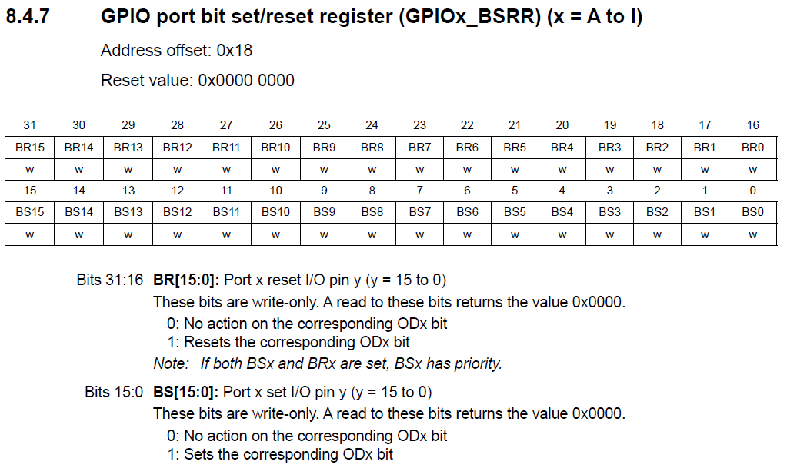

### Alternate Function Low[7:0] and High[15:8]

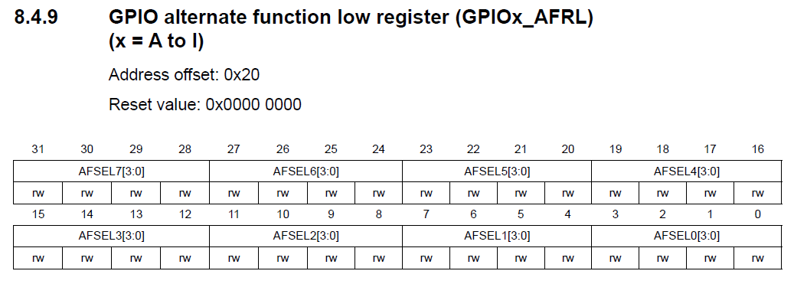

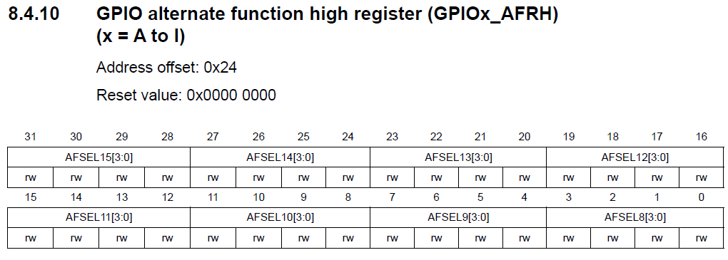

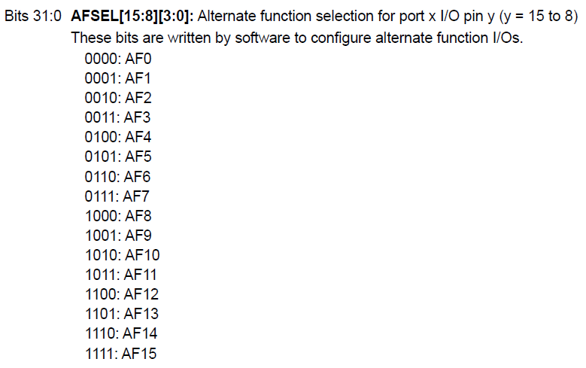

*For both GPIOx_AFRH and GPIOx_AFRL

### Bit Reset Register(For output LOW)

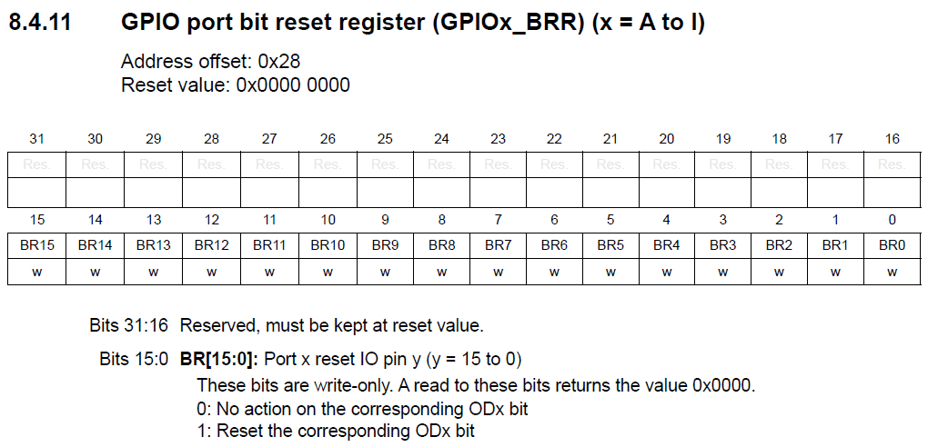

# I2C Protocol

* Bus-based, multi-master, low-bandwidth, short distance, synchronous, serial, in-band addressing (7-bit slave address), 2 wire, half-duplex.
* Number of ICs connected is limited by bus capacitance.

## Speeds

|  |  |  |  |
| --- | --- | --- | --- |
| Standard Mode | 100 kbit/s | Fast-mode Plus | 1 Mbit/s |
| Fast-mode | 400 kbits/s | High-speed mode | 3.4 Mbit/s |

*Not all devices capable of all modes, standard mode most common.

## I2C Signals

Open drain lines with pull up resistors.

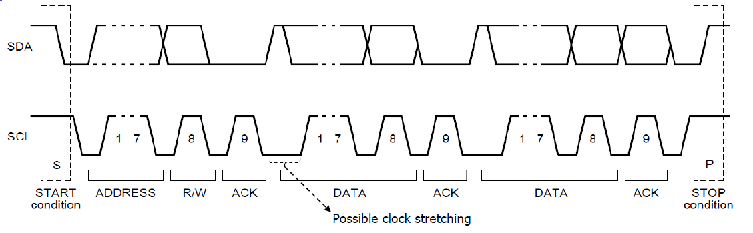

START(S): SDA goes low during SCL HIGH

STOP(P): SDA goes high during SCL HIGH

Rest of the data only changes when SCL is LOW

$$R/\overline{W}: 0 →WRITE, 1 →READ request$$

## Master Transmitter/Receiver

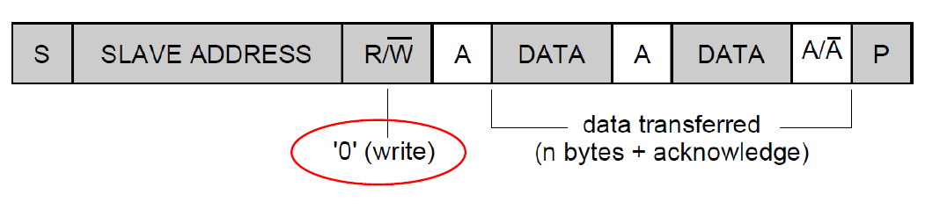

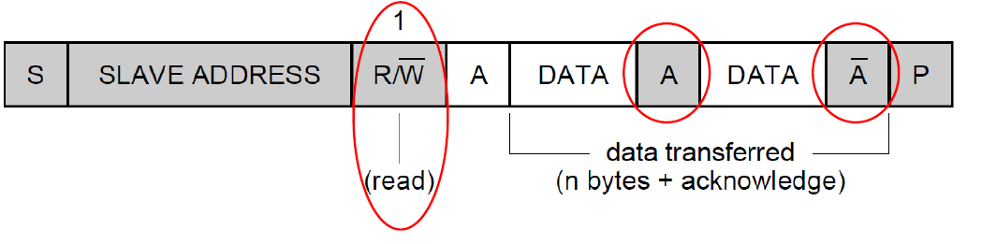

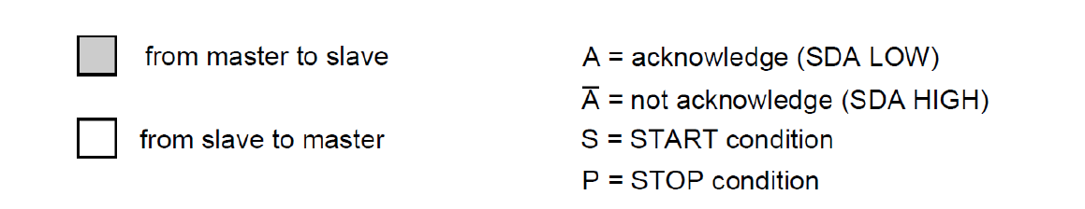

* Note that for Master Transmitter, the master can either send a P or a $Sr$ (repeated start) for change of direction. This prevents other Masters from controlling the bus.

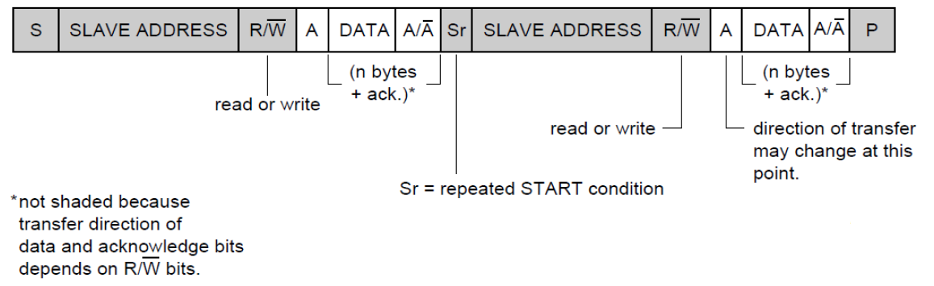

* Master $\overline{A}$ (NACK) sent to tell slave that no more bytes required. Slave $\overline{A}$ has no standard meaning.

## Clock Stretching

By the slave device, when it cannot receive or transmit another complete byte of data until it has performed some other function. It holds the clock line (SCL) LOW to force the master into the wait state.

## Bit-banging

Other pins can also be used for a software-based (software-intensive, inefficient) implementation of I2C - a technique known as bit-banging.

## Note

Library functions are written to favor ease of use / flexibility, but compromises on performance /battery life.

* Performance and battery life matter in many real-world applications when we move past the prototyping stage.
* Use of interrupts (instead of polling TXIS and RXNE) can make it much more efficient.

## Write/Read of I2C Slave Register

### Write

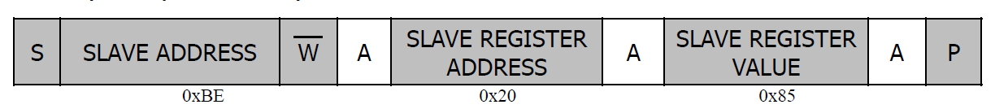

### Read

Write then read normally using $Sr$

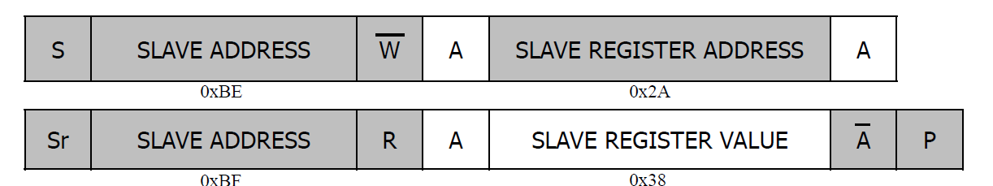

*Note that the addresses are different for this example. 0x5F is the 7bit slave address. 0xBE is the 8bit slave address + W[0] while 0xBF is the 8bit slave address + R[1]

### Autoincrement

Can be used to read multiple registers separated by one bit in a single transaction.

The master reads two bytes in a single read transaction. The first byte is the content of the register whose address was written in the preceding write. The second byte is the content of the register with address++, i.e., a pointer internal to the slave keeps track of which register is read, and increments it with each byte read.

## STM32 I2C Registers

### I2C_CR1(Basic Ctrl/Enable)

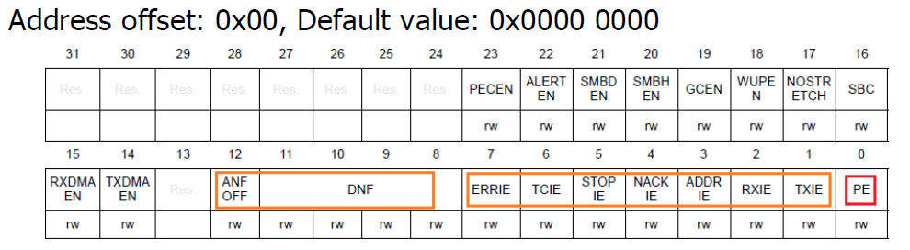

1. Write 0 to PE to disable and perform soft reset of interface

2. Set Analog and Digital noise Filters

3. Configure I2C Master Clock (SCLH and SCLL bits in I2C_ TIMINGR)

4. Enable interface by writing 1 to PE.

### I2C_RXDR(Receive Data Register)

Bits 7:0 – Content from SIPO shift register which samples serial data on SDA in receive mode.

### I2C_TXDR(Transmit Data Register)

Bits 7:0 – Data written here is copied into PISO shift register which sends the data serially on SDA in transmit mode.

### I2C_CR2(Communication Control)

Information related to one transfer in master mode.

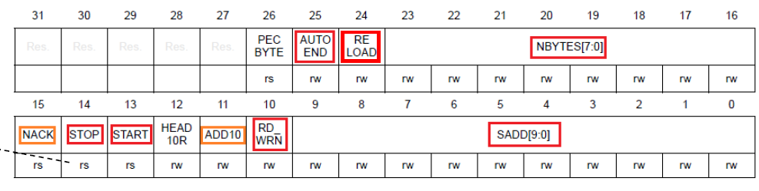

NBYTES used to indicate the amount of data received.

* If AUTOEND is set, then after NBYTES are received, a P is automatically generated. Else, TC* is set, which stretches SCL. STOP/START must be written to send P/Sr.
* If RELOAD is set, transfer is not completed after NBYTES are sent, and it must be reloaded.

START = 1 – Master mode and set S condition if bus is free

STOP = 1 – Generate P after current byte transfer

RD_WRN = 0 in write, 1 in read

### I2C_ISR(Interrupt and Status Registers)

Status and interrupt status bits set by hardware and cleared due to action by software.

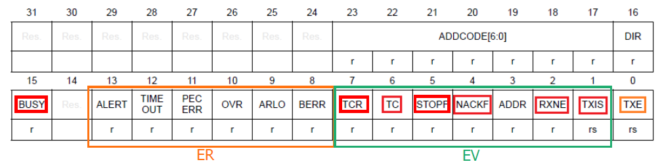

TCR: Transfer Complete Reload

* RELOAD = 1, NBYTES data transferred

TC: Transfer Complete (Master Mode)

* RELOAD = 0, AUTOEND = 0, NBYTES data transferred
* Cleared when sw sets START or STOP bit.

RXNE: Receive data register not empty.

* Received data is ready to be read from I2C_RXDR
* Remains set between 8th and 9th SCL Pulse before sending ACK.

TXIS: Transmit Interrupt Status

* Set when I2C_TXDR register is empty, after 9th SCL pulse when ACK received and NBYTES left > 0.

STOPF: Set when stop condition has appeared on bus.

NACKF: Set when byte sent is not acknowledged by receiver(slave)

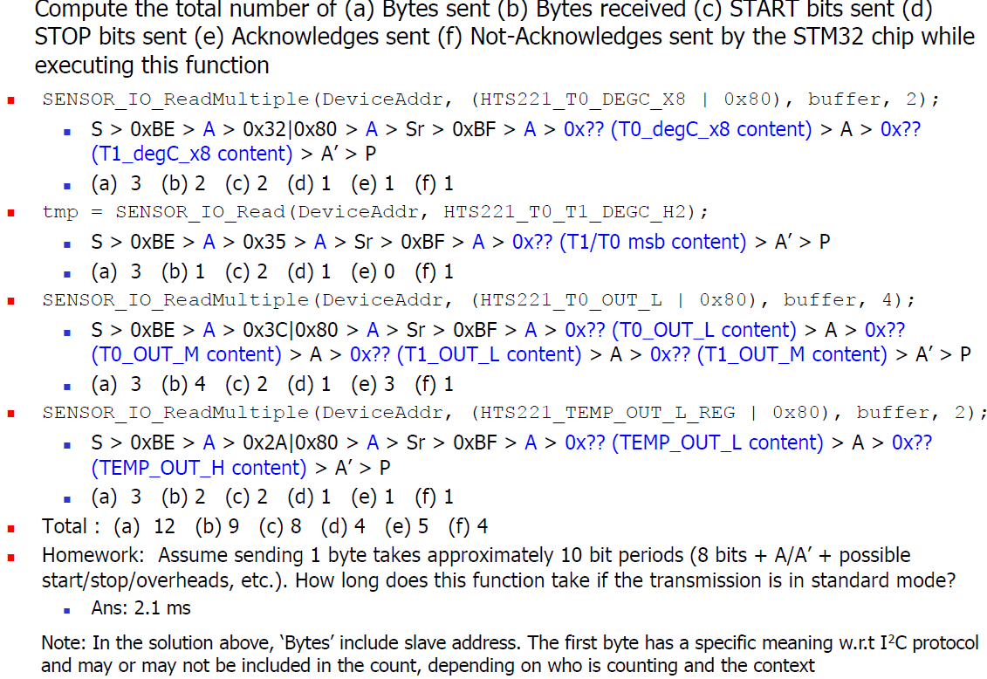

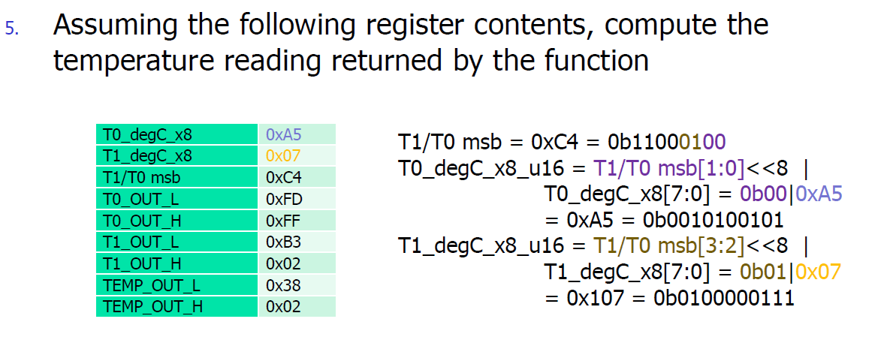

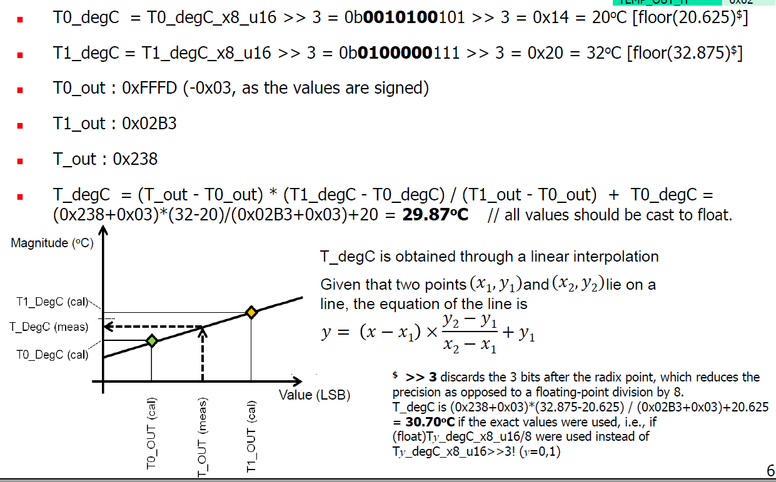

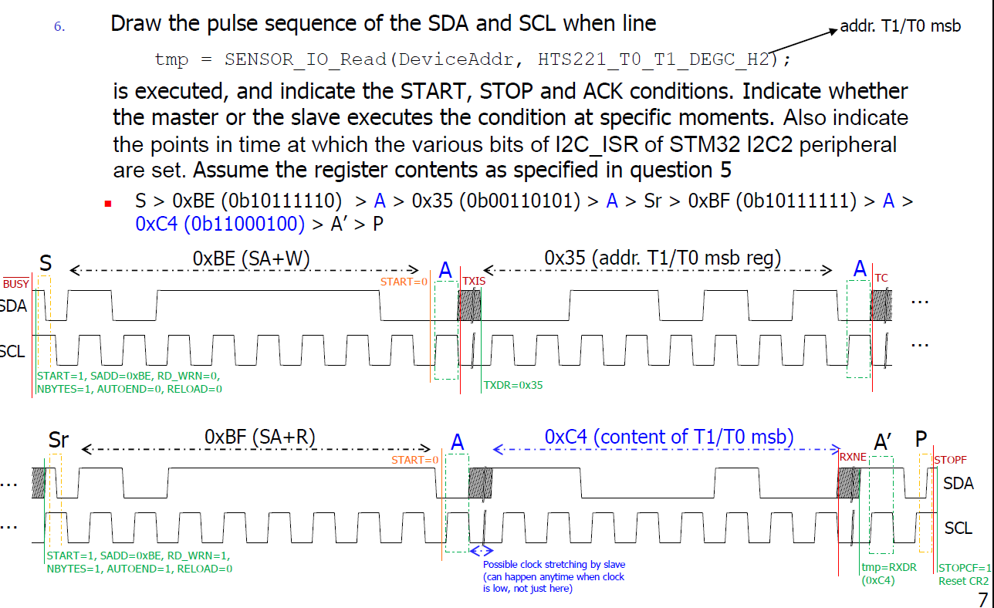

## Flags that are set

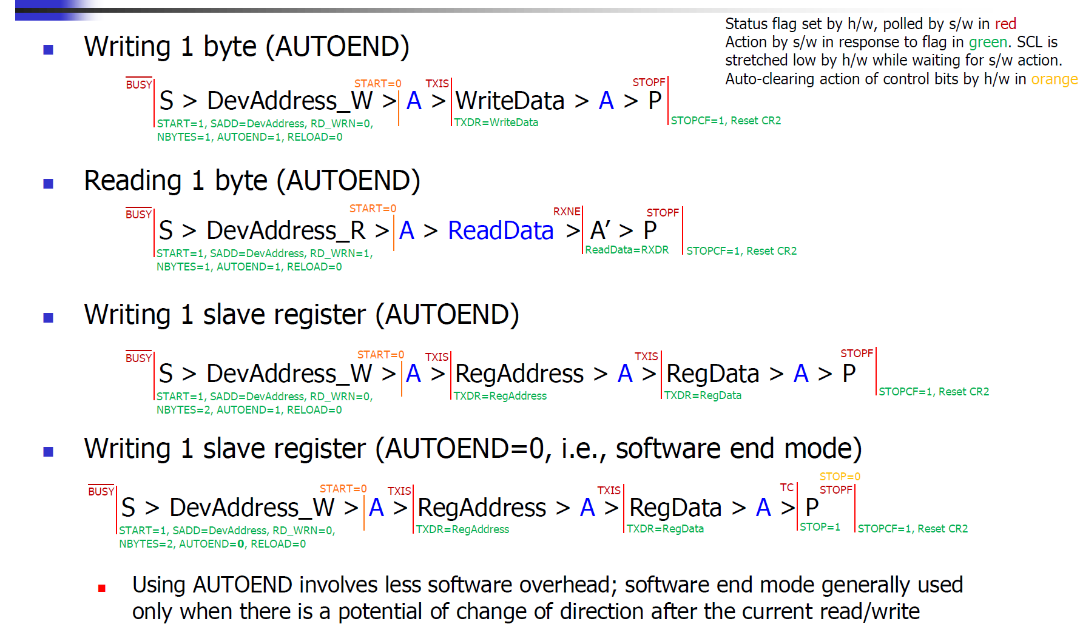

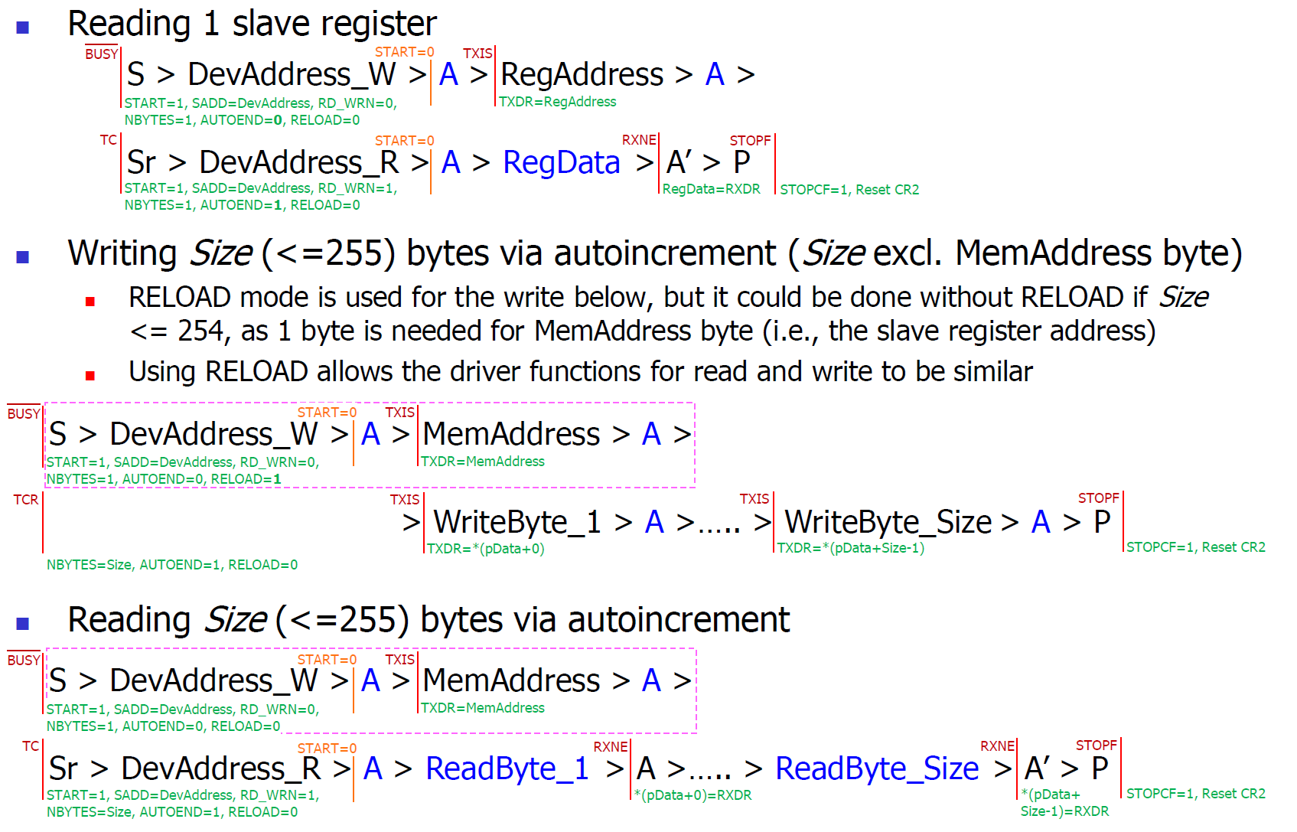

# Interrupts & NVIC

Interrupts are more efficient since CPU can do other work. However, they are harder to design, debug and test.

There is **overhead/latency** as CPU must stop working, determine the device requesting the service, save its work (Status: R0-R3, SPI, LR…) before serving the request.

## Interrupt Groups

### System Exception

* Exception number 1-15
* Reset, NMI, Bus fault, Usage fault.

### External Interrupt

* Generated by on-chip peripherals

## Priority Levels

Higher Priority(Lower levels) can pre-empt lower ones

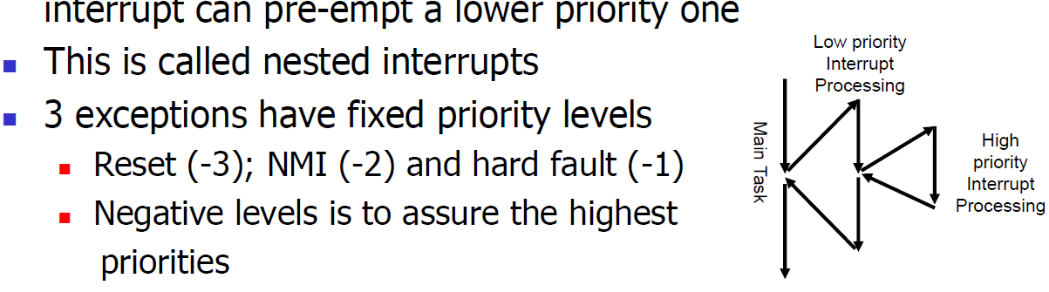

*Note that exception number is used as a tie-breaker (sub-sub-priority) if 2 interrupts have the same priority setting.

There are up to **256** priority levels(*0xFF*), up to **128** levels of pre-emption.

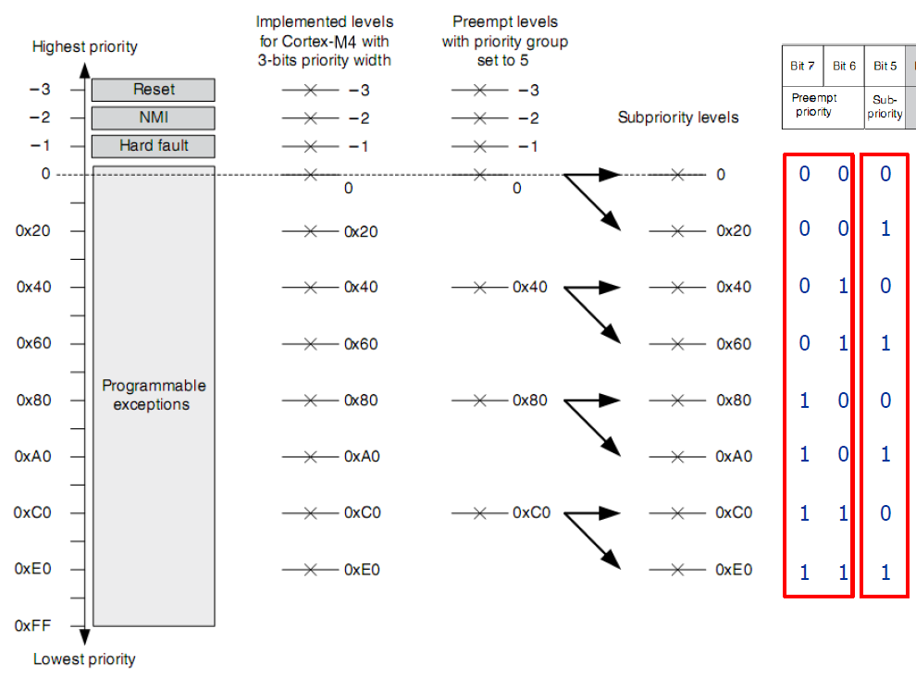

|  |  |
| --- | --- |
|  |  |
|  |  |

### Pre-empt Priority

Defines whether an exc./int. handler can execute when CPU is running another exc./int. handler.

### Sub Priority

When 2 exceptions/interrupts with the same pre-empt priority have occurred and are pending. Higher sub priority one will be handled first.

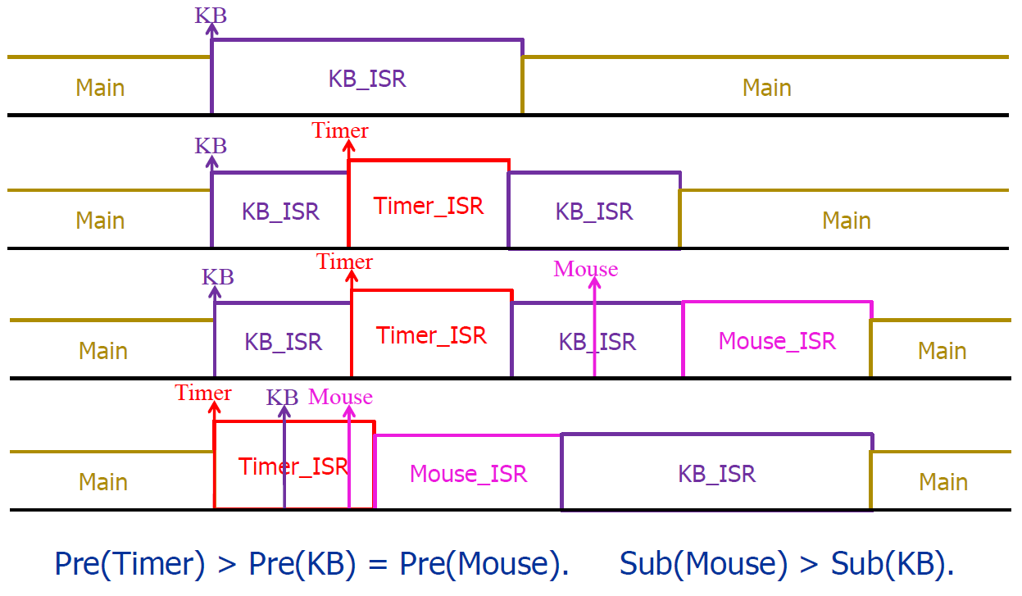

## IPR Width

Each exc./int. has an Interrupt Priority Register (IPR) stores that stores its pre-empt(left bits) and sub-priority (right bits) values.

It has 8 bits but not all might be implemented. **For STM32, 4 bits, so 16 programmable priority levels**

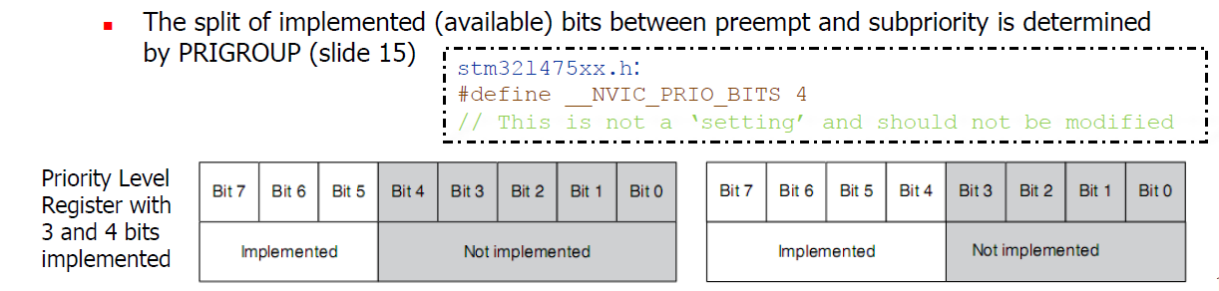

The division of pre-empt and sub-priority bits is decided by the **PRIGROUP** in AICR (Application Interrupt and Reset Control Register) in System Control Block (SCB)

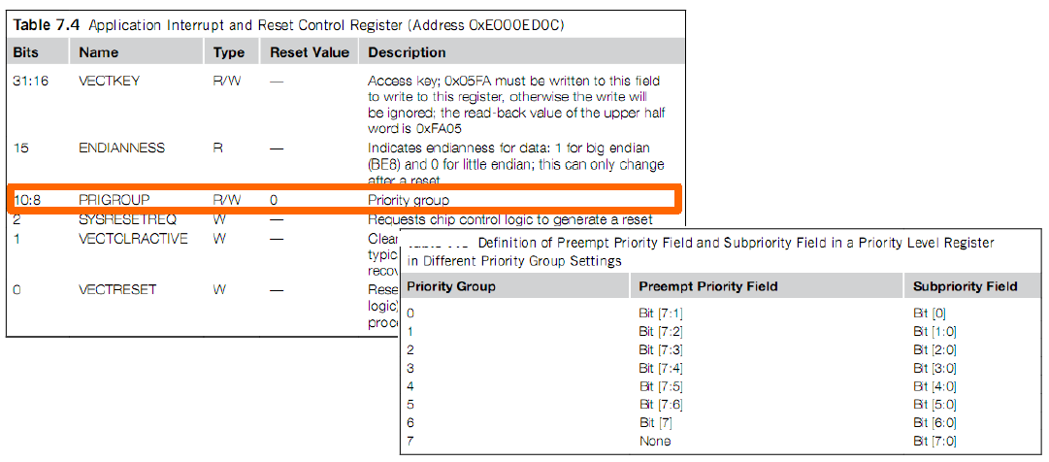

## Interrupt Pending Behaviour

When the exc./int. is asserted, it is pended until the int./exc. handler starts. (exc./int. is waiting for the cpu to process)

When the int. handler is executed, it then becomes active and the pending bit is cleared.

Pending bit can be cleared before CPU response by writing to an interrupt control register in NVIC

*Note: ONLY happens when enabled.

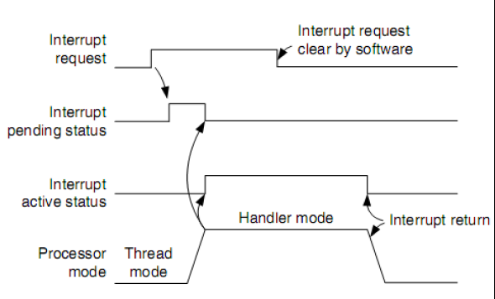

An int. that is signalled several times before it is processed will treat it as a single int. request.

If the int. source continues to hold the int. request signal active, the int. will be pended again at the end of the ISR. (When interrupt not cleared)

## Vector Table

Part of memory used to store the starting addresses of the various exception/interrupt handlers.

* Address arranged to exc./int. number x 4 as an interrupt vector takes 4 bytes.
* Vector table starts at memory address 0 which is the stack pointer. The first exception is at 0x04.
* Exception 40 is found in 40x4 = 160 = 0x 0000 00A0
* Can be relocated to another memory location by setting Vector Table Offset Register (VTOR) in SCB

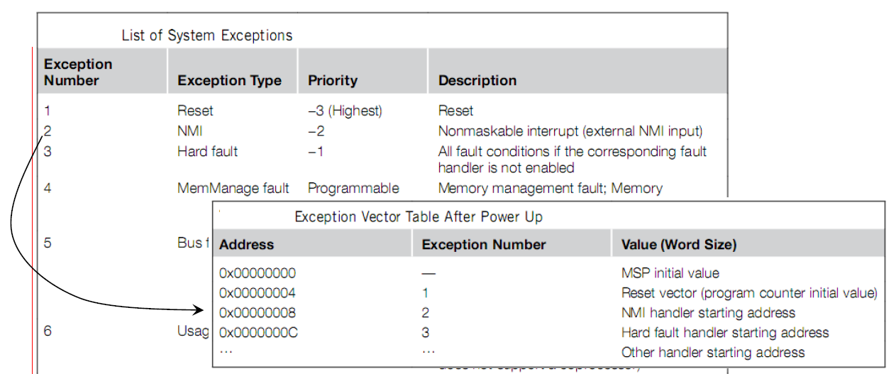

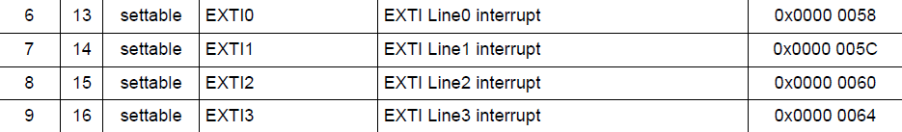





Note that EXTI0 – EXTI4 are treated as separate interrupts, while lines in EXTI15_10 and EXTI9_5 treated as the same interrupt (within each EXTI) and will have the same priority.

# EXTI

Management of external and internal asynchronous events/interrupts and generates event request to NVIC.

## SYSCFG_EXTRICRn

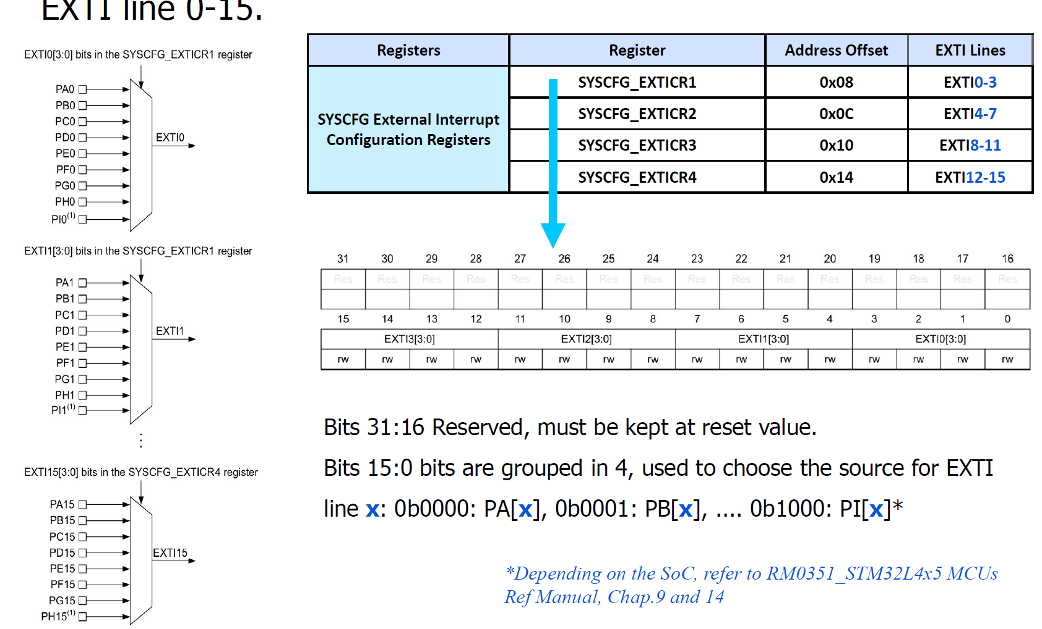

Each CRx register can configure pin x. Then in that register, write different values to activate interrupt at different ports.

E.g, EXTICR1[15:12] is for pin 3.

Write 0000 to activate PA[3].

0001, 0010, 0011 & 0100 for PB[3], PC[3],PD[3] & PE[3].

## EXTI Memory Map

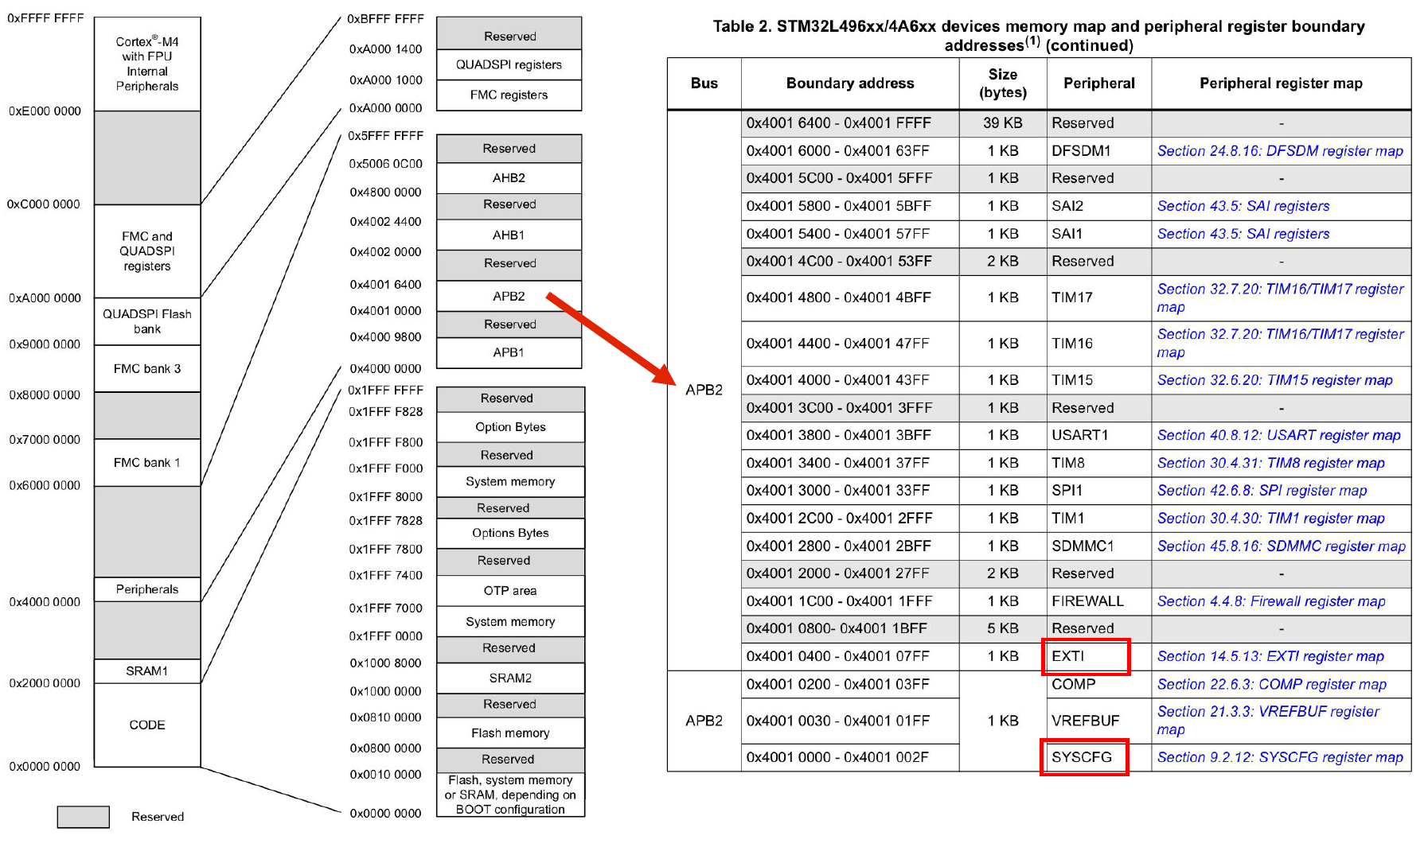

## EXTI Registers

|  |  |
| --- | --- |
| EXTI_IMR | Interrupt Mask, bits [15:0]. 1 to enable interrupts |
| EXTI_RTSR1 | Rising Edge interrupt. 1 to enable |
| EXTI_FTSR1 | Falling Edge interrupt. 1 to enable. |
| EXTI_PR1 | Pending interrupt. 1 when selected trigger request has occurred. Must be cleared by writing 1 to the bit. Else it will keep entering the handler. |

*Can set both EXTI_RTSR1 and EXTI_RTSR1 for the same interrupt lines

Steps

1.Enable AHB2 bus for GPIO Ports

2. Configure SYSCFG_EXTICRn to chose Port and Pin as EXTI Source.

3. Configure EXTI_IMRn

4. Configure EXTRI_FTSRn/EXTRI_RTSRn

5. Enable IRQ in NVIC

# Interrupt Programming

Can have more than one, as each bit is one interrupt. For STM32, 82 external interrupts so there are 3 (82//32 = 3) of each register.

## Interrupt Registers

NVIC_ISER(32 bits, RW): enable interrupts (write 1).

NVIC_ICER(32 bits, RW): disable interrupts (write 0).

*Both can be read to check interrupt status. (INT enabled or disabled)

NVIC_ISPR(32 bits RW): force interrupts into pending state

NVIC_ICPR(32 bits RW): clear pending interrupts

*Both NVIC_ISPR, NVIC_ICPR can be used to check for pending interrupts

NVIC_IPR: Write priority level (0-255) of interrupt.

NVIC_IABR: Determine which interrupts are active. Bit set to 1 if interrupt handler is being executed.

## System Exceptions

Controls are part of System Control Block (SCB) a CORE PERIPHERAL.

SHPR: Priority of system exceptions with programmable priority levels

ICSR: To set and clear pending status of system exceptions and determine currently executing exception/interrupt number using VECTACTIVE.

SHCSR: Enable usage faults, memory management faults, bus faults. Pending and active status also available.

PRIMASK: set to 1, only allow NMI, hard fault and reset exceptions. PRI $≥ 0$ are disabled.

FAULTMASK: Allow NMI, reset exceptions. PRI $≥ -1$ disabled.

BASEPRI(8bit): For disabling exceptions/interrupts of priority number $≥$ BASEPRI. 0: disables BASEPRI.

## Steps

1. Set priority group setting: number of bits for pre-empt priorities. NOTE: less is better as system loses time saving and restoring system state during preemptions.

2. Set priority level of interrupt (Default 0).

3. Implement ISR

4. Configure interrupt generation, peripheral + mcu.

5. Clear pending status in NVIC

6. Enable interrupt in NVIC

## Implementation

1. PUSH all registers modified + (R0 – R3, R12, LR, PC, xPSR).

2. Check cause for interrupt by checking which pin, or whether falling/rising edge.

3. Do the bare minimum to deal with the cause. Higher priority – make ISR shorter, no blocking code. Volatile flag for variables modified.

4. Clear pending status in interrupt device.

5. POP all registers pushed at beginning.

# EXTI Registers

### EXTI_IMR1

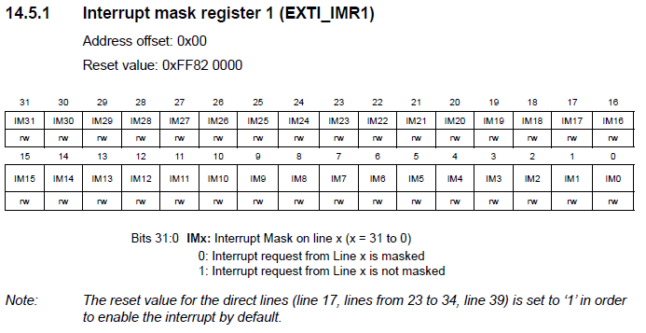

### EXTI_RTSR1

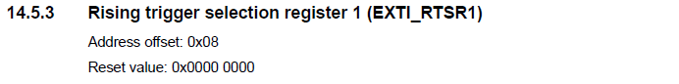

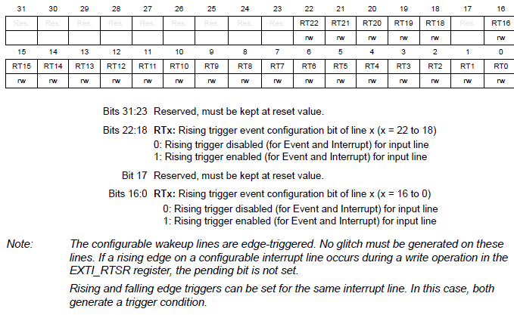

### EXTI_FTSR1

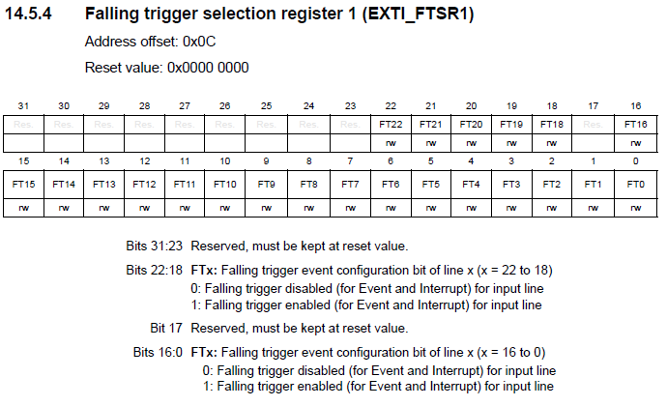

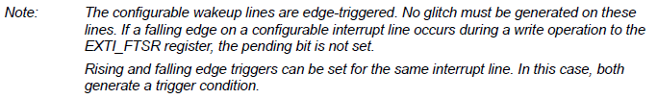

### EXTI_PR1

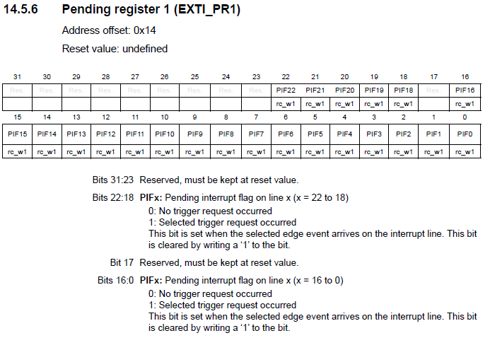

# Interrupt Programming

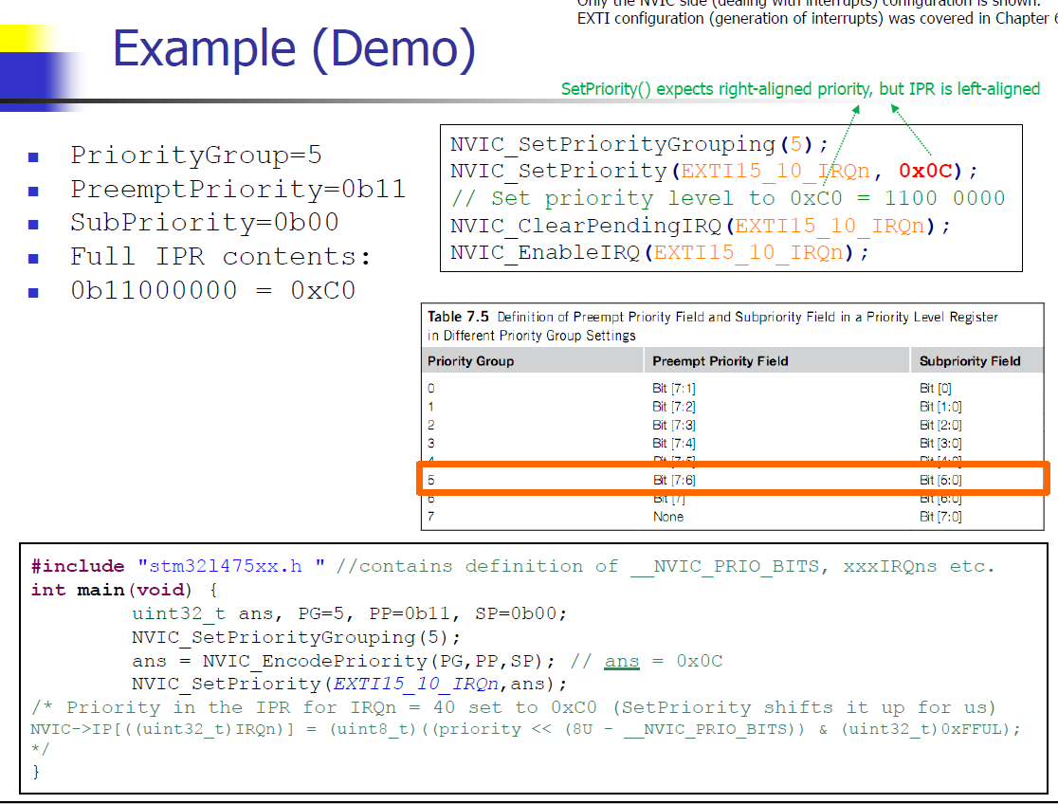

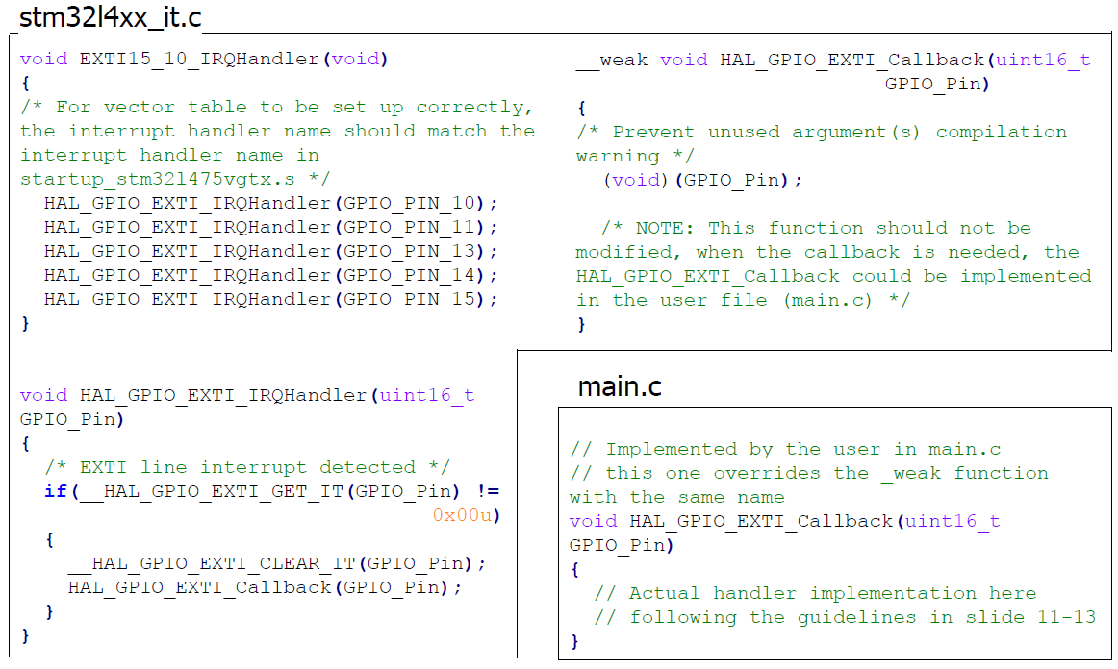

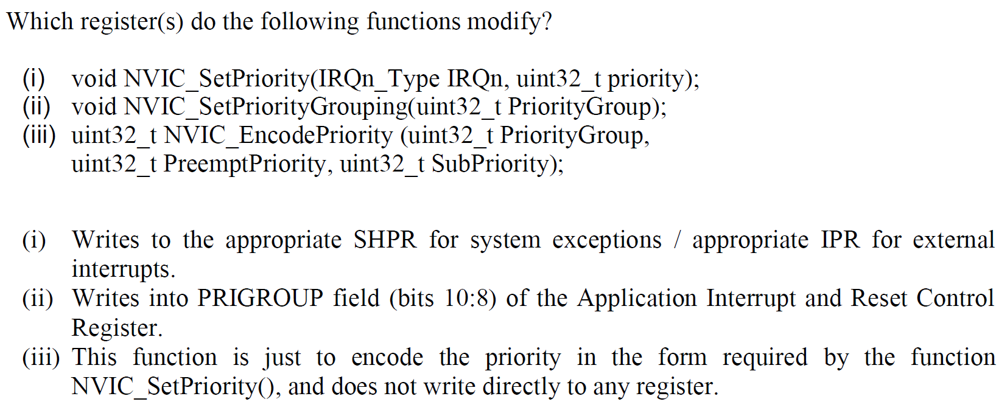

### START button Handler

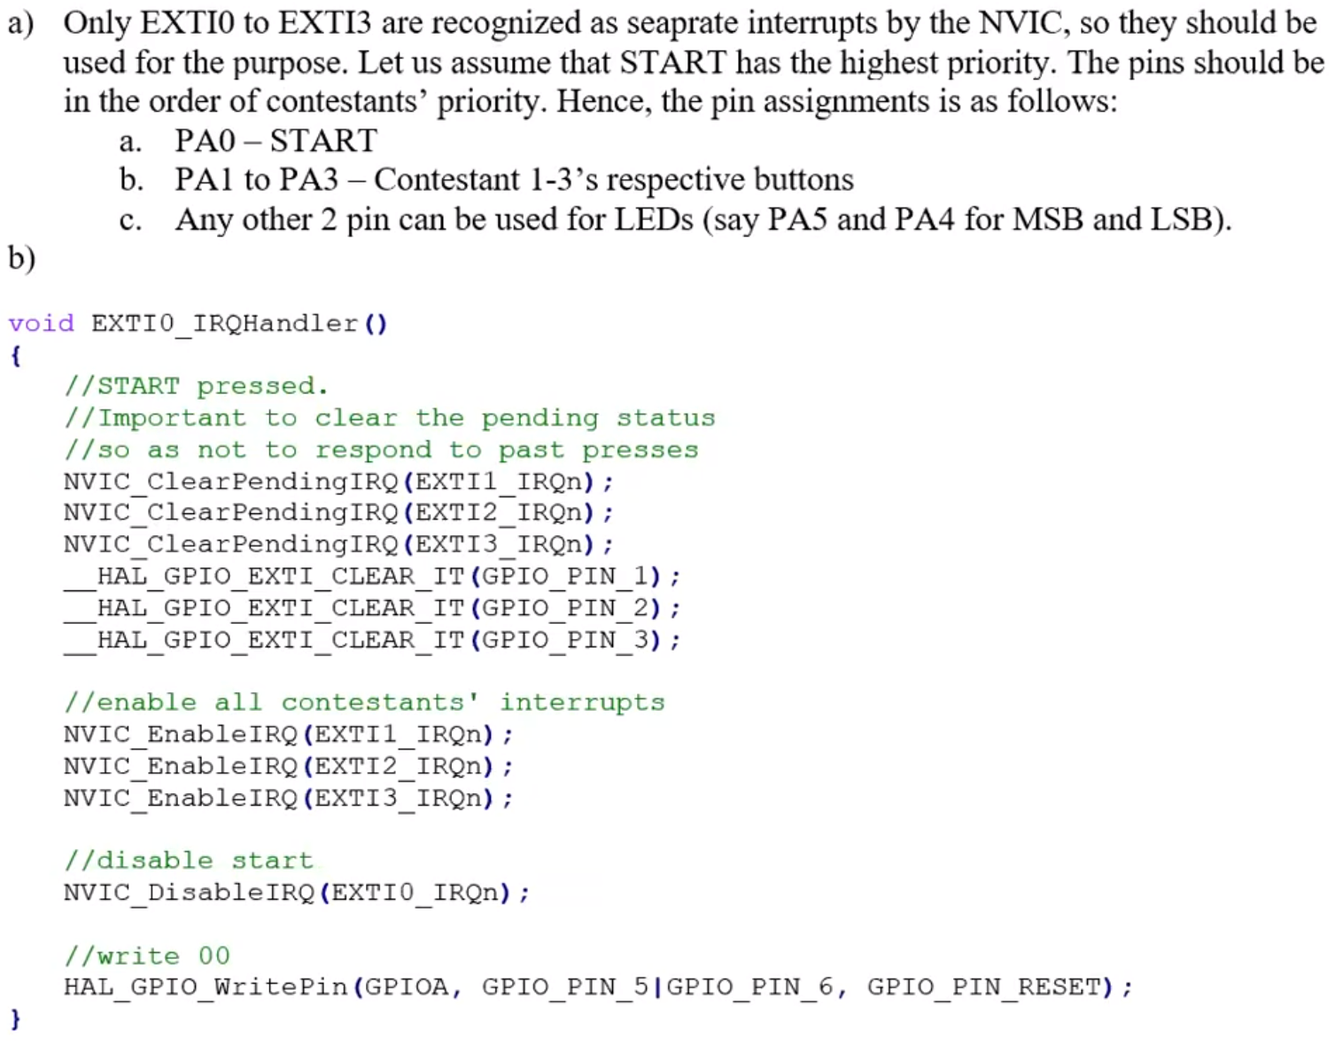

### Participant Button Handler

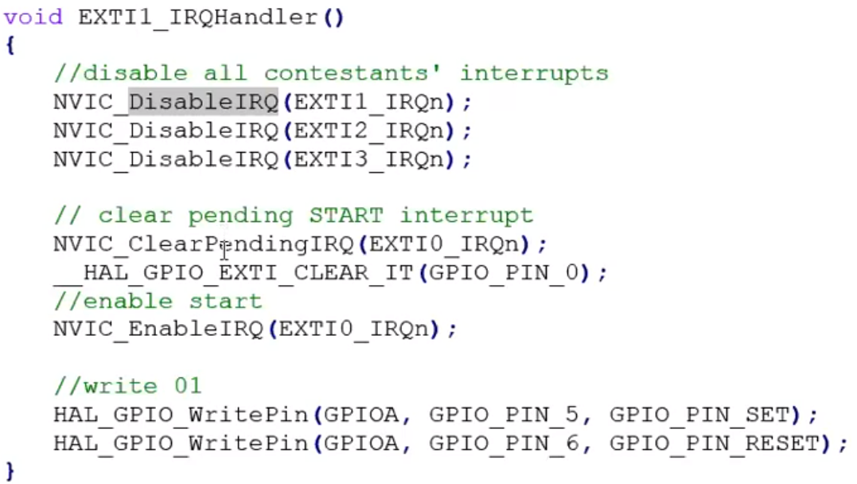

# UART Intro

*Note that I2C (100000)and UART (115200)are quite comparable in speed.

Hardware for long-distance, asynchronous, serial, point-to-point, peer-peer, full duplex communication.

Transmitter: Takes bytes of data and transmits bits sequentially using a PISO shift register.

Receiver: Assembly bits into bytes using SIPO.

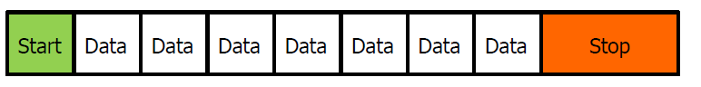

Each character (8 bits) sent as a frame with

* Start: Logic LOW
* Data bits (word length, usually 8) LSB first normally
* Optional parity bit(bit error detection)
  + Parity bit is because UART is meant for long distance and there is a high chance for data corruption. Common check is using XOR
* End: One or more logic HIGH bits
* Line remains high until next start bit.

## Receiver

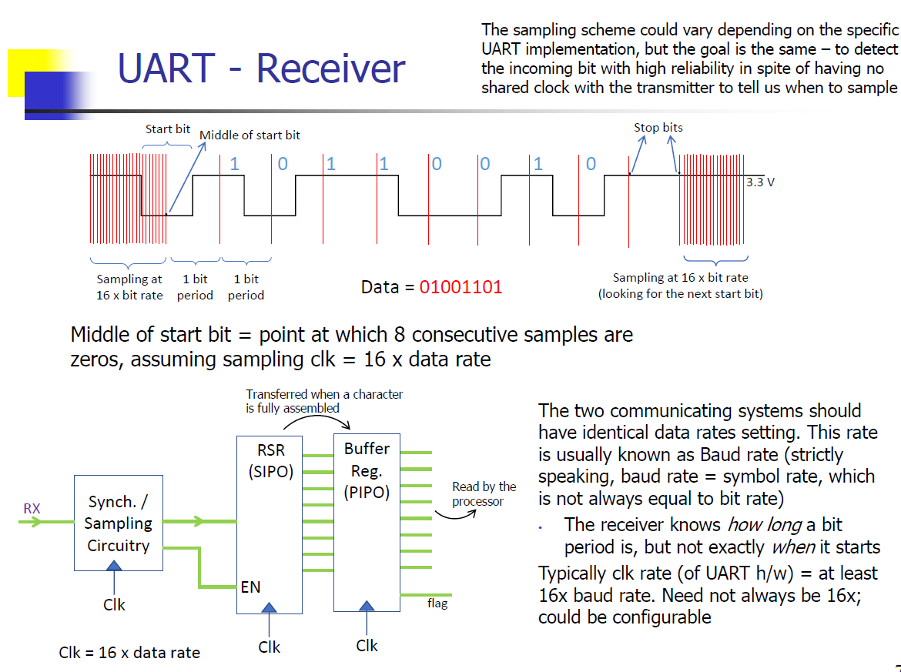

* Has more complicated hardware. Has a clock signal that samples 16x the data rate. It samples the data to look for the incoming start bit.
* Start bit is only valid if it lasts for at least one-half of the bit time, else it is discarded.
* Data can be copied into a buffer register so that a new character can be received while the current character is being read.
* FIFO buffer memory can be inserted between receiver shift register and host processor for time to read data and prevents loss of data at high rates.

## Transmitter

When data is deposited into shift register, UART hardware generates start bit, shifts data bits onto line, generates parity bit and generates stop bit. During this time, the UART maintains a busy flag so a new character is not deposited.

Note that there is TX and RX, 2 different circuits (shift registers inc) for transmitted and received characters.

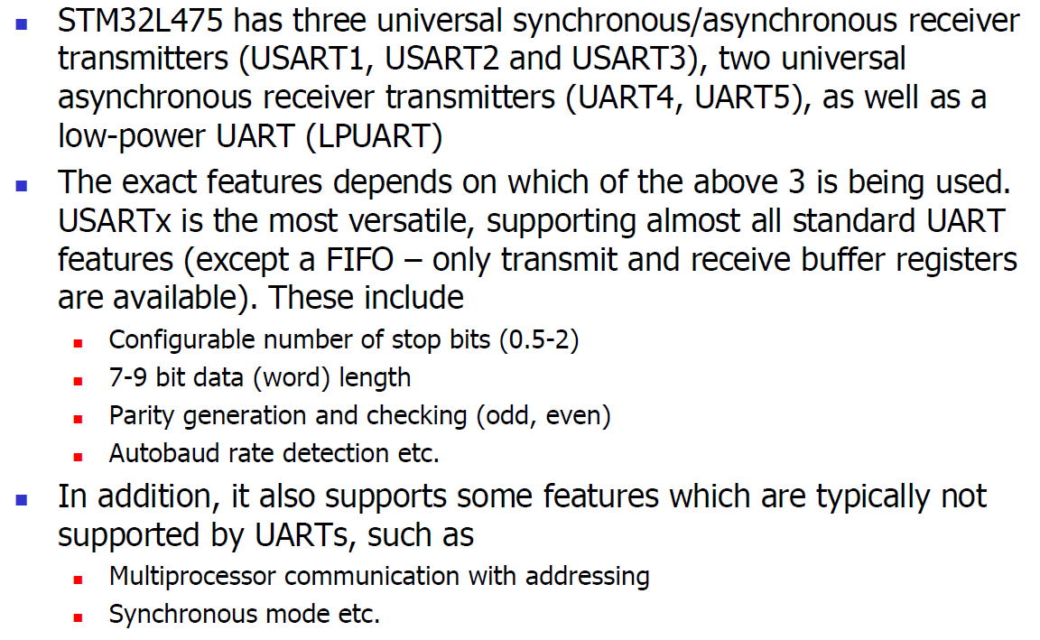

## UART HAL Functions & Registers

